THE MYTH OF THE PERCEIVED RIGHT HAND FINGER GRIP
WHY IT IS IMPOSSIBLE!

SCIENTIFICALLY, THE MOST USED GRIP IS THE MOST DISADVANTAGED RIGHT HAND GRIP POSSIBLE
- Creates two axis in the primary power system -- the right arm
- Two axis causes maximum mechanical difficulty in squaring the club face
  - Only World Class Athletes with many hours a day to practice can become efficient with a two axis right arm system.
Armed with this information, the following statements can be made:
- Even though 99% of PGA tour players and 99% of all other golfers use a two axis system,
IT IS STILL NON-OPTIMUM!
The last thing you should ever want to do, in any sport, is to copy the dominant player of the time. Virtually none of them use scientifically optimum mechanics.

There is an interesting perception that a grip can be placed along the finger of the right hand. It is actually; anatomically impossible to hold a grip in the right hand fingers and make an effective golf stroke.
The two pictures below illustrate this incorrect perception.

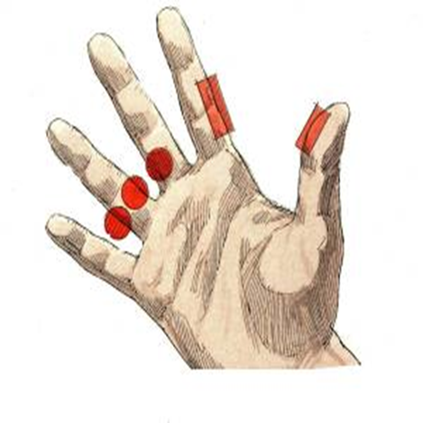 | 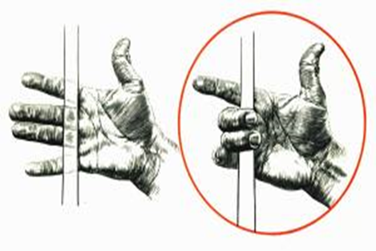

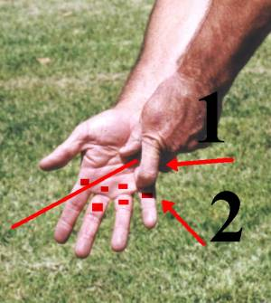
An observation of the placement of the right hand little finger (arrow 2) over the left hands first finger (arrow 1) makes it impossible for the grip to get below the placement of the left hands first finger (red line illustrating the lowest points across the right hand).

Since this finger is approximately 1/2" above the knuckle next to the right palm, the grip cannot be lower than this point.

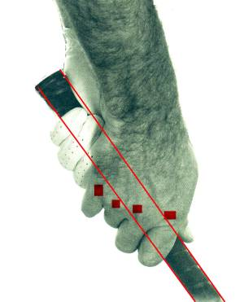
Observing the grip of most tour professionals, the grip looks similar to the two photos.
- There are two to three knuckles below the grip,
- One knuckle in the center of the grip,
- The grip cannot be in the fingers.

The first finger joint of the right hand is the only one that can be above the grip.

