Putting and the Putter

The bottom line on putting is a cliché:
IF YOU THINK YOU CAN OR THINK YOU CAN’T, YOU’RE RIGHT!
You must absolutely be confident that you will sink the putt.

I have built and tested numerous putters. I have tried virtually every putter that has been made by other manufacturers. The number of new putters and marketing hype claimed by the golf industry has flooded the market to a degree that science and truth no longer exist.  In this environment, announcing a new putter that is a superior scientific design may seem foolish! However, as you know, when I discover something that will allow you to control the distance and direction of your putt, I will offer it to you. | 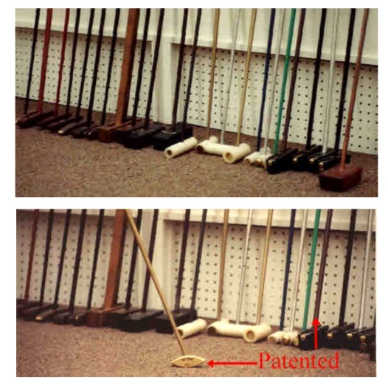

Announcing the “BLACK-MAGIC” Putter (Hand Made in the USA)

- Shaft in line with ball impact;
  - No twisting from ball impact
- Shaft installed at the Center-Of-Gravity;
  - Perfect balance to eliminate torque on the head.
- Shaft bent at two inches above the head;
  - This allows the shaft to be bent to your natural hand position for making a perfect piston motion.
  - A special grip allows your dominant palm to consistently square the clubface at impact.
- Non-Snag Attachment on Bottom;
  - Eliminate snagging in the backstroke and forward stroke
- Non-Glare Black Matte Finish
- No sight lines;
  - Eliminates vision distortion; everyone’s eyes see lines differently!
- No Loft;
  - Allows immediate overspin for a better roll of the ball for distance and direction.

Designing the “Black-Magic” Putter

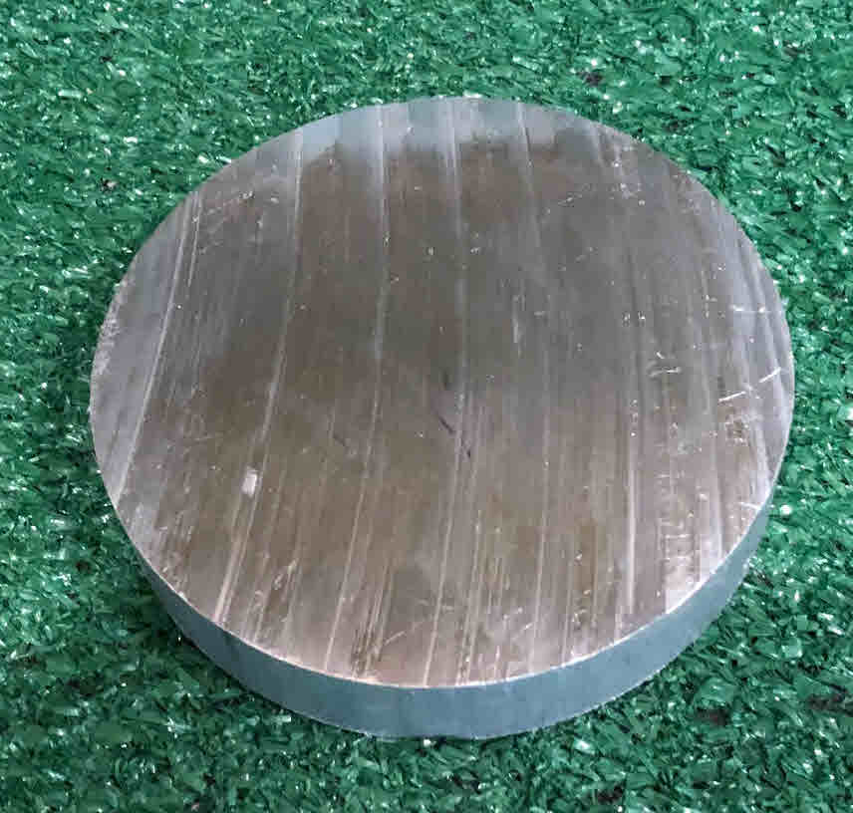 | 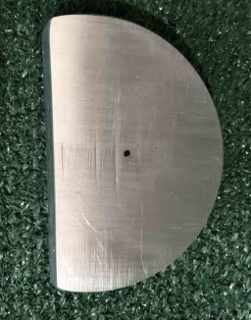 | 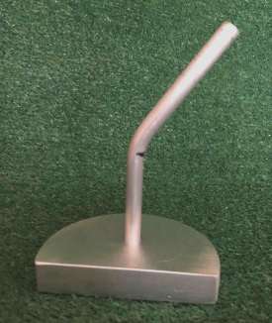
Starts with a rough round slice of aluminum. | A section is milled off to produce a flat NO loft face. | An aluminum rod is epoxied in the center of gravity and bent to your natural hand position. | The Non-Snag piece is attached to the bottom of the head.

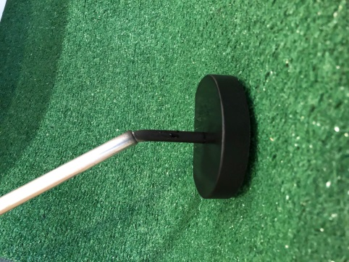 | 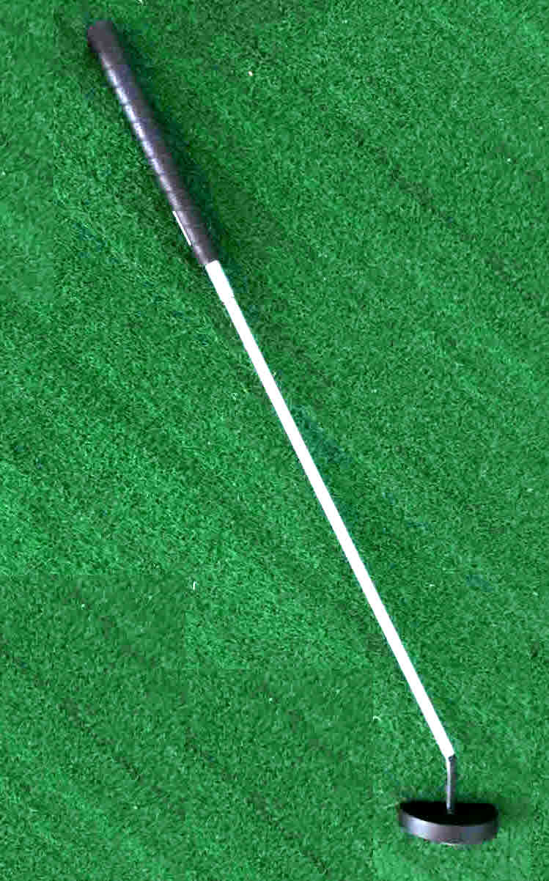 | 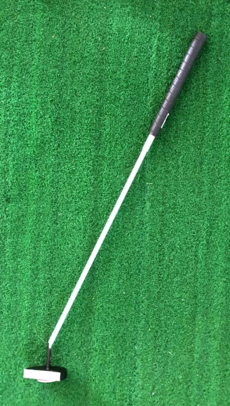
A black matte finish is applied to the head. | Back View | Front View

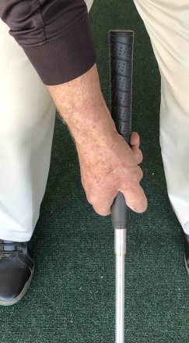 | 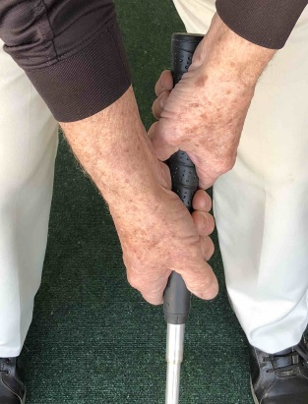 | 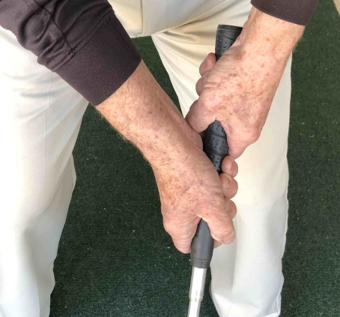
The balance of the “Black Magic” putter allows for the hands most natural piston motion grip.

The cost is $175.00 + $15.00 S&H

Seniors and Military is $125.00 + $15.00 S&H

