Cycle Motion of a Spring - No Gravity

BS(Broken Symmetry Math) – SM(Symmetry Math)

Many process in nature move back and forth across an initial rest position. I am renaming this process cycle motion (CM) to distinguish it from BS math Simple Harmonic Motion. The following CM example is a mass attached to a spring that is cycling back and forth on an air bed which virtually eliminates friction and gravity:

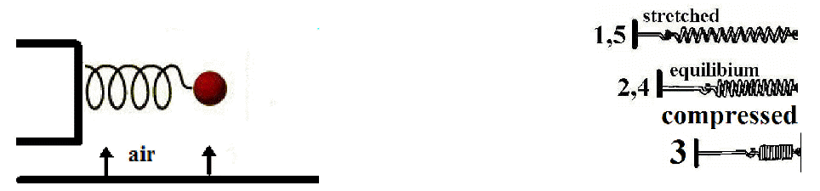

An Action is needed to stretch or compress a spring to a starting point where it can execute cycle motion.



*  (ts: to start) is the required to move a mass attached to a spring a distance (d1) from its initial rest position.
* , the spring constant is the stiffness of the spring
  + A is attraction
  + R is repulsion
  +  is for the back-and-forth motion through the zero initial rest position. A stretched spring goes from “A” to “0” to “R” to “A” to “0” to “R”
* *d1* is the distance a mass is moved from its initial rest position.

Once is performed to move the mass to position *d1* (against the restraint of the spring), a % of the is transferred into the spring as **potential attraction/repulsion** (PAR). There is always more performed than is stored as PAR. When the spring is released from the restraining *Ats*, the PAR starts the oscillation.

Conservation of requires that the PAR and the motion  be a constant.

  

 :

 is ½ the height from the base to the peak of a cycle.

An experiment of moving paper under a pendulum through a small angle filled with sand that can escape through a small hole in the bottom shows that a pendulum cycling back and forth follows a curve that is mathematically analogous to a ‘sin’ or ‘cos’.

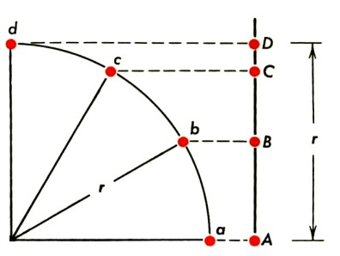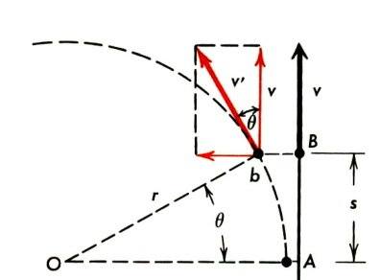

The projection of the curved area onto the straight line exactly duplicate the back and forth motion of CM. This allows for the math of ‘sin’ or ‘cos’ to be used.

SM will use ‘sin” math. It could use ‘cos’ or a combination of both ‘sin’ and ‘cos’. Using just the ‘sin’ math makes the understanding and math easier.

|  |  |
| --- | --- |
|  |  |

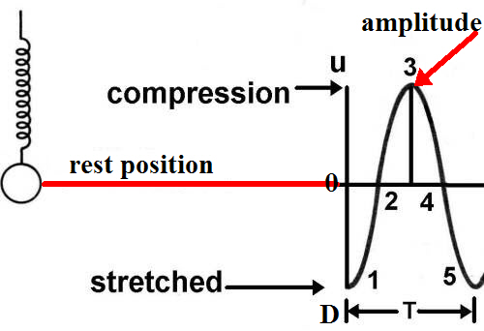

The diagram at the left shows a spring being stretched from its (zero rest) position-2 and the PAR being released at position-1. There are 4 sections (1 to 2; 2 to 3; 3 to 4; and 4 to5) that alternate between maximum acceleration and zero velocity to max velocity and zero acceleration.

* At position-1, there is maximum acceleration and zero velocity.
  + The ‘sin’ values from 0o to 1.57o will be used for velocity (values from 0 to 1).
  + The ‘sin’ values from 1.57o to 0o will be used for acceleration (values from 1 to 0).
* At position-2, there is maximum velocity and zero acceleration. Acceleration changes to deceleration.
  + The ‘sin’ values from 1.57o to 0o will be used for deceleration (values from 1 to 0).
  + The ‘sin’ values from 0o to 1.57o will be used for acceleration (values from 0 to 1).
* At position-3, there is maximum acceleration and zero velocity.
  + The ‘sin’ values from 0o to 1.57o will be used for velocity (values from 0 to 1).
  + The ‘sin’ values from 1.57o to 0o will be used for acceleration (values from 1 to 0).
* At position-4, there is maximum velocity and zero acceleration. Acceleration changes to deceleration.
  + The ‘sin’ values from 1.57o to 0o will be used for deceleration (values from 1 to 0).
  + The ‘sin’ values from 0o to 1.57o will be used for acceleration (values from 0 to 1).
* At position-5, the cycle starts again.

In the SM system, a radian and an angle are the same. The radian or angle measurement provides for the projection of the curve onto the straight line of the CM. This radian or angle values provide the exact velocity, acceleration and deceleration at a specific point on the CM line. The graph below shows the values for each 0.1o of the CM of the straight line.

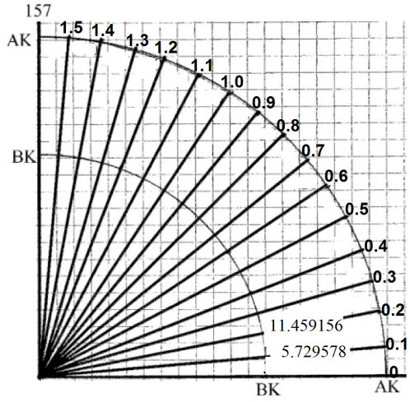

----1o is 1 radian in SM

Radians or degrees

|  |  |
| --- | --- |
|  |  |



Conversion chart from BS math to SM.

Initially,  is needed to compress or stretch the spring. Once the spring is compressed or stretched, we label it PAR. The equation for the is.

* If the spring is stretched 0.1m, the will be one times K to stretch it to the start position.
* If the spring is stretched 0.2m, the  will be two times K.
* If the spring is stretched 0.3m, the  will be three time K.

If we perform on the spring and stretch it to position (1) from its zero rest position (2&4) and then release it, CM will occur.

z-shm-compressed spring 3

z-shm-stretched spring 1&5z-shm-equilibrium spring 2&4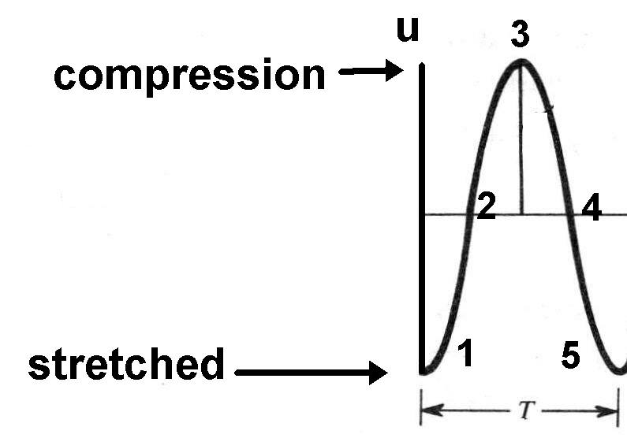

The amount of PAR expended in performing the work on the spring or pendulum is always greater than the potential created in the spring or pendulum. For example, when you contract a muscle to move a mass, heat is expended in contracting the muscle. If the mass moves,  is performed. If the mass does not move, no  is performed on the mass, but a sizeable amount of heat is expended in trying to move the mass (contraction of muscles).

Once the system is set into motion, the force exerted by the spring, is always directed so as to push (repulse) or pull (attract) the system back to its zero or rest position. For a mass at the end of a spring, the stretched spring attracts the mass back toward the rest position, while the compressed spring repulses the mass back toward the zero or rest position. The height is the distance the compressed or stretched spring moves from position 1 to 3.

When a mass attached to a spring is stretched to position-1, the spring will Attract (accelerate) the mass toward its ‘0’position-2. When the mass passes through the ‘0’ position-2, the spring will Repulse (decelerate) the mass until it reaches its maximum compression position-3. At position-3, the spring will Attract the mass toward its ‘0’ position-4. When the mass reaches position-4, the spring will repulse (decelerate) the mass until it reaches position-5 – the end of the cycle.

* Maximum acceleration occurs at positions (1,3 and 5).
* Acceleration changes to deceleration at positions (2 and 4)
* Maximum velocity occurs at positions (2 and 4)
* Velocity is zero at positions (1,3 and 5)

The CYCLE-TIME (Tc) of a vibrating system is the TIME for the system to complete one full cycle (move from position 1 to 5). The motion is in a straight line joining the end points of the motion. The projection of ¼ of a circle (‘sin’ or ‘cos’ math) on to the straight line of the CM are just useful tools for obtaining correct answers. The motion of a mass attached to a spring is a straight line.

The FREQUENCY (*f*) is the number of cycles in a second.

We designate the letter T to be the time for one cycle.

Therefore,  is the number of cycles in one second.

How many T’s in one second (count the number of peaks or bases in one second)?

The height of one cycle is the distance from 1 to 3.

|  |  |
| --- | --- |
| z-shm-jk notation | Amplitude =1/2 d  ___  |  |  d  |  | __ |

The T for the drawing above is 0.3 seconds per cycle. The frequency will be:



Answers for height, velocity, acceleration, frequency, and cycle-time in CM are found by solving the Attraction-Repulsion equations for a spring:

**Acceleration equation derived**

AR=Kd

(A) is Attraction



(R) is Repulsion

(K) is the spring constant

(d) is the displacement from equilibrium

The arrow subscript for ‘K’ is the direction of the spring resistance.

The arrow subscript for ‘d’ is the distance and direction of travel of the object attached to the spring.

This is for a stretched spring.

 Attraction-Repulsion = (Mass)(acceleration)

Equating these two equations for , we have 



 **Acceleration:** Initial Acceleration is equal to a constant (the ratio of the stiffness of the spring divided by the resistance of the mass) times the initial distance from the rest position of the spring.

**Velocity equation derived**

Conservation of requires that the potential  and the motion be a constant. 



  is ½ the height of a cycle.

Multiplying both sides by 2

yields  

 **Velocity at any point during the vibration.**

**Velocity equation derived for maximum velocity**

‘*v*2 (velocity at position 2)’ is a maximum when‘d’ is at the zero rest position 2. Therefore,‘d’ is ‘0’ at that point.

 substituting ‘0’ for ‘d’ gives, 

 **Velocity at position-2 and position-4 (maximum).**

**Cycle-time equation derived**

The cycle-time (Tc) of (VM) is the time taken for the mass to move from position-1 to position-5.

**Cycle-time**





**Acceleration in terms of the cycle-time (Tc)**



Substituting  into the ‘Tc” equation yields:

Acceleration can now be solved in terms of “Tc1-5’ by eliminating the  between the two equations



 Square ‘T” and rearrange: 

 **Acceleration equation when ½ the height and cycle-time are known.**

Summary of the equations:

|  |  |
| --- | --- |
|  | spring constant (K) when mass (*M*) and cycle-time (T) are known. |
|  | spring constant (K) when mass (*M*) and amplitude ( d1) are known. |
|  | velocity (*v*) at any point during the cycle |
|  | velocity (*v2*) maximum (when d = 0 at position-2 and 4) |
|  | acceleration (*a1*) maximum when spring constant (K),  mass (*M*) and amplitude (d1) are known. |
|  | acceleration (*a1*) maximum when amplitude (d1) and cycle-time (Tc) are known. |
|  | acceleration (*a*) at any point during the cycle-time (T) |
|  | cycle-time (Tc) when amplitude (d1) and velocity (v1) are known. |
|  | cycle-time (Tc) when mass (*M*) and spring constant (K) are known. |
|  | cycle-time (Tc) when the frequency is known. |
|  | frequency (*f*) when the cycle-time (Tc) is known. |
|  | frequency (*f*) when the number of cycles in an elapsed time is known. |
| d1 | amplitude (distance from rest to start position).  Also: ½ the distance from the base to the peak. |

Solved Examples of Cycle Motion

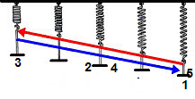

Example: A spring initially at rest at **position 2-4** is stretched to **position 1-5** and released.

* The **mass** attached to the spring is = **1000 grams = 1 Kg**
* The **amplitude** is ½ of the height from the base to the peak = **100 cm = 1 meter = 1m**
  + Total distance mass moves during one cycle is **400 cm = 4m**
* The **cycle-time (T)** for one cycle is = **1 sec**

Solve for:

* (a) the frequency (*f*)
* (b) the spring constant (K)
* (c) the maximum speed of the mass
* (d) the maximum acceleration of the mass

(a) the frequency:



(b) the spring constant (K):



(c) the maximum speed of the mass is at v2 or v4:



(d) the maximum acceleration: (at a1 or a3)



**UNITS**: (k) has units of N/m. N = F=ma = (Kg) (m)/(sec2) = [(Kg)(m) / (sec2)(m)] = Kg/sec2

Example: For the U,D motion shown below, what are:

* Amplitude (d1)?
* 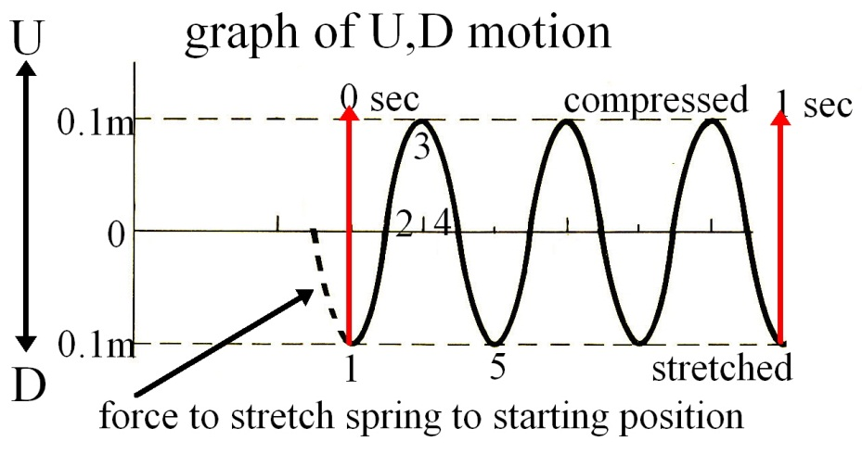Cycle-time (T)?
* Frequency (*f*)?
* Amplitude:
  + The amplitude is ½ the distance from the base to peak of a cycle. From the graph, the amplitude is 0.1m.
* Cycle-time:
  + The cycle-time is the time for one up and down cycle (position 1 to position 5). From the graph, the cycle-time is 0.33 seconds/cycle.
* Frequency:
  + 

Example: A spring moves through 10 cycles in 50 seconds. What is the:

* Cycle-time (T)?
* Frequency (*f*)?





Example: A 50 gram mass (0.05 Kg = 0.05E3g) cycles at the end of a spring.

* The amplitude (d1) of the motion is 10 cm (0.1m)
* The cycle-time (T) is 2 seconds.

Find the:

1. Frequency (*f*)?
2. Spring constant (K)?
3. Maximum velocity (v2) of the mass (M)?
4. Maximum acceleration (a1) of the mass (M)?
5. Velocity when the displacement (d) is 5 cm?
6. Acceleration when the displacement (d) is 5 cm?

1. 

2. 

3.

4. 

5.

6. 

Example: A 0.1Kg mass hangs at the end of a spring. When 0.05Kg more mass is added to the end of the spring, it stretches the spring 0.1m more. Find the:

* Spring constant (K)?
* The cycle-time (T) of the original system when the 50g mass is removed.

 **F to K derived**

* 
* 

Example: A golf shaft is clamped at the butt end and a 1 Kg weight is placed on the tip end. The tip moves 0.05 m. What is the:

* Butt to tip (48”) shaft constant K?
* The cycle-time (T)?
* The frequency (*f*)?







A real shaft with a driver head of (0.2Kg) will be around 250 cycles/min. If T = 0.25, then *f* = 240.

A golf club shaft changes stiffness from the butt to tip. It will be a gradual change from the butt to the tip. Do measurements on several shafts to see the point where the stiffness is equal to the actual. Guessing that it will around the center of gravity.

The use of the ‘sin’ or ‘cos’ makes the differential equation of motion very easy to achieve the correct answers for straight line motion with the projection of the curve on to the straight line.



the derivative of the ‘cos’ is the ‘sin’ and the derivative of the ‘sin’ is the ‘cos’. The derivative of sin 0o to 1.57o is the sin 1.57o to 0o. The same goes for the integral

**Illogical BS math coordinate system**

In BS math system, an illogical coordination system is used. The zero was picked at equilibrium and negative numbers were assigned to the lower half of the cycle (directions in space were labeled positive and negative [whatever that means]). There is nothing negative about the lower half of the cycle, just as there is nothing positive about the upper half. In one case a spring is compressed and the other it is stretched. Neither is the negative or positive of the other. It is attractive or repulsive. There are no negative numbers and there is no negative work. The BSM system requires a brute memorization of meaningless – (dashes) and + (crosses) and produces many incorrect answers due to an illogical and incorrect Rule-of-Signs.

