Bubba Watson

Most tour players learned their mechanics during their youth. They have unique swings that are easily identifiable to a golf enthusiast. Bubba Watson is an excellent example. His mechanics do not fit any teaching mold.

99% of tour golfers use a 2-axis, 4-lever trailing arm system. Physics demands that they move on 5 different planes that move up during the downstroke. Statistics for tour players show they have effective accuracy approximately 70% of the time. 100 years of statistics prove that this is a maximum for the 2-axis, 4-lever trailing arm system.

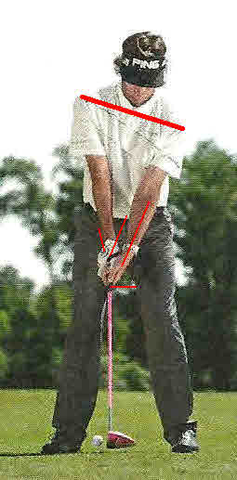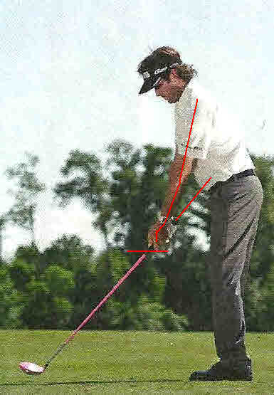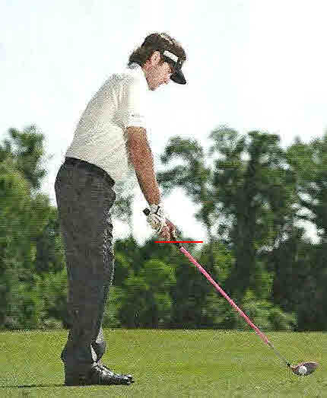
Address: Bubba uses a strong right hand grip (knuckles on top of the grip). He also uses a strong left hand grip (thumb pointing at left shoulder). The middle photo shows the 2-axis, 4-lever trailing arm. All three photos show the bottom of his trailing hand at address.

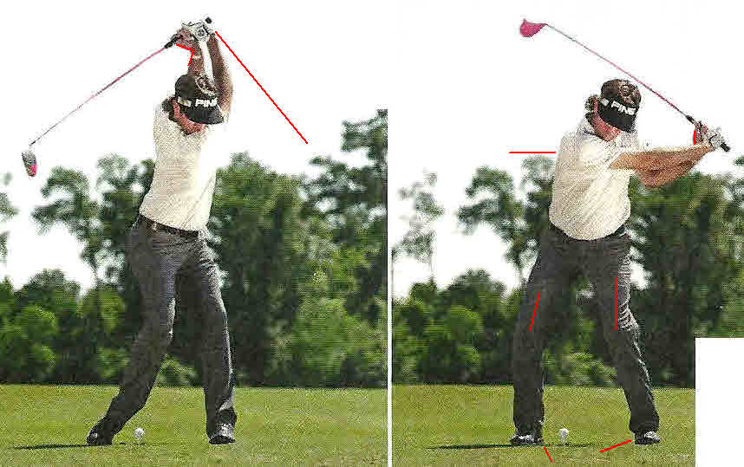
The start of the downstroke is three simultaneous motions;
- The hands move backward and downward with no uncocking of the wrist.
- He sits into his knees.
- He keeps his back to the target.

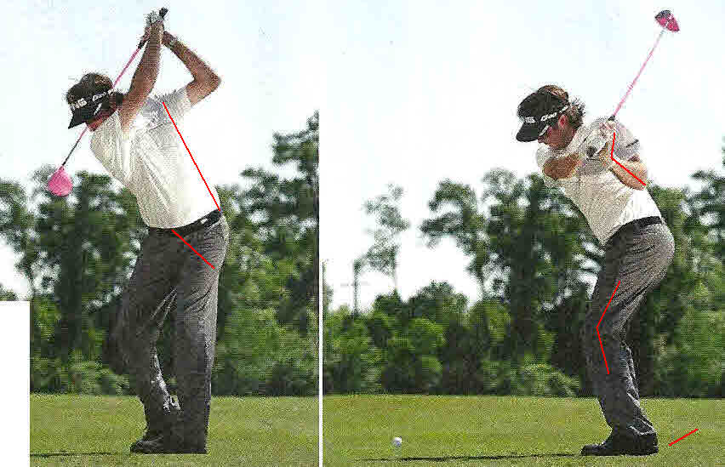
There is minimal torqueing of the shoulders to the hips.

Bubba firmly plants both feet for stabilization.

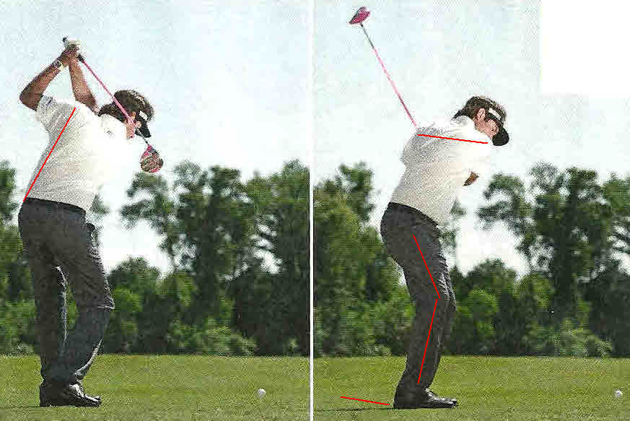
Again:
: Back and down with the hands
: Sit into the knees
: Keep the back to the target
: Both feet flat on the ground for stability

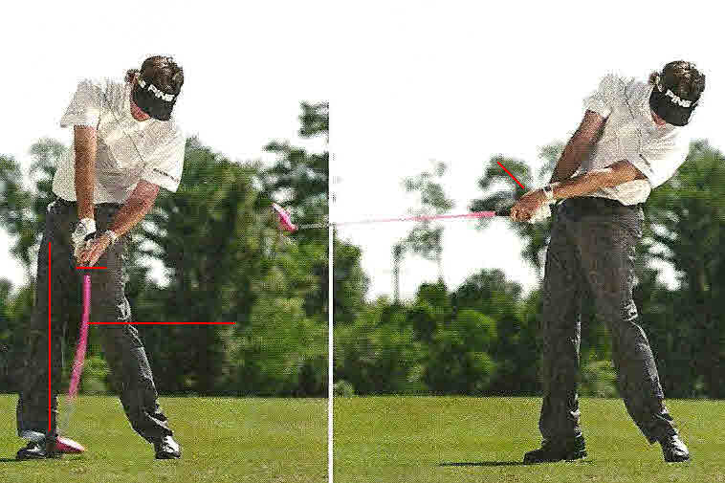
From the position above, he straightens the leading leg. This is an attempt to align the 2-axis (Never Happens).

Body center moves upward and backward. The hands are substantially higher at impact than address.
Bubba builds a tremendous wrist stretch reflex in his left wrist. When the reflex kicks in, his clubhead speed reaches maximum.
This shaft bending is a camera shutter speed problem. The shaft is not bending as shown.

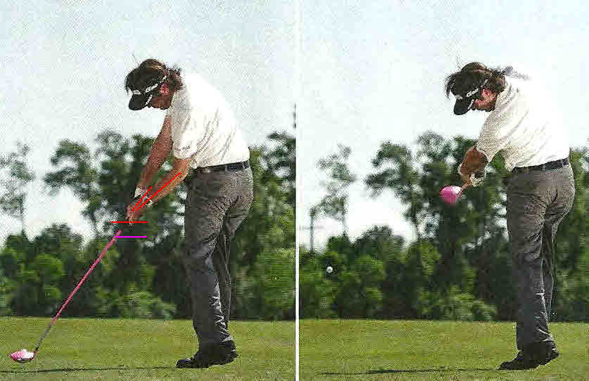

The left photo shows the 2-axis trying to straighten with the hands substantially higher than at impact.

The pink line was his hand position at address. The red line is his hand position at impact.

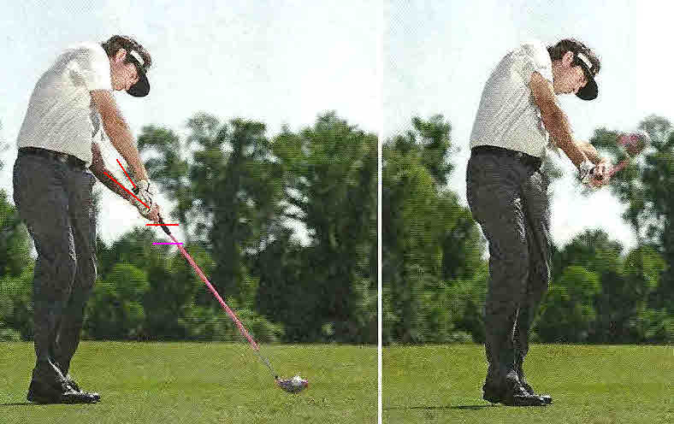
Same as above from a different view.

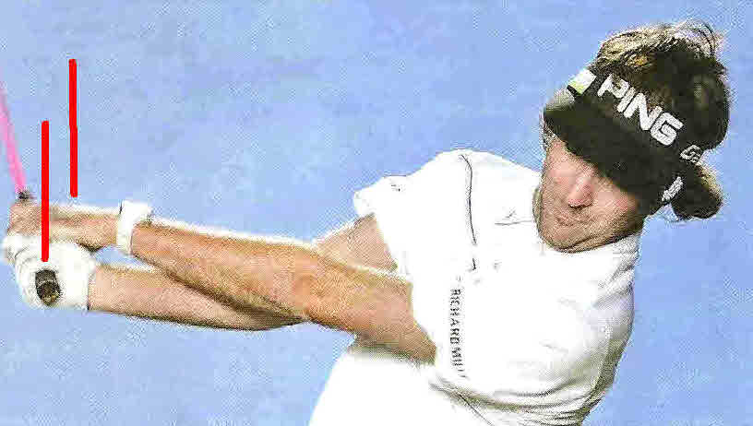
Bubba rips his left forearm over his right forearm during the follow through.

The majority of tour players established their mechanical motion brain patterns playing junior golf. These patterns allow the highest chance of being reproducible. Any time a tour player tries to change his/her mechanics; it will never be as coordinated as the patterns they developed as a youth.
Bubba is a perfect example of different mechanics being very effective. If he ever tries to change, the chance of him losing his current tour level scoring ability will increase.

