**SYMMETRY MATH (SM) versus BROKEN-SYMMETRY (BS) MATH**

By Jack Kuykendall Email: [Kuysg@aol.com](mailto:Kuysg@aol.com) ©2005

|  |  |
| --- | --- |
| SM | BS |
| C:\Users\JACK\Documents\Science USB 5-1-2018\Removable Disk\SYMMETRY-MATH\JK math\sci - exponential\e -2a.jpg | C:\Users\JACK\Documents\Science USB 5-1-2018\Removable Disk\SYMMETRY-MATH\JK math\sci - exponential\exp graph.tif |
| All SM graphs are symmetrical; both sides of the graph are the same. | BS has numerous broken symmetry graphy; left side of graph is different from the right side of the graph. |
| No negative numbers | Negative numbers |
| No positive numbers | Positive numbers |
| All numbers exist | Numbers that do not exist |
| No imaginary numbers | Imaginary numbers |
| No absolute values | Absolute values to change negative answers into positive answers |

Table of content

|  |  |
| --- | --- |
| Section 1 | Why is SM needed? |
| Section 2 | BS rule-of-signs cannot be proved! |
| Section 3 | Code breaking; breaking the dash (-) cross (+) codes |
| Section 4 | SM versus BS |
| Section 5 | Why a ; a dash times a dash does not equal a cross |
| Section 6 | BS number line; visual of ILLOGICAL math |
| Section 7 | Two observer errors and distributive error |
| Section 8 | SM; 6.28 degree or radian circle |
| Section 9 | SM versus BS for absolute values for displacement |

Section-1

Why should Symmetry-Math (SM) replace Broken-Symmetry (BS) Math?

In January of 2005, I discovered numerous errors in the current Broken-Symmetry (BM) math system.

* The current math system is a broken-symmetry (BS) math system. The math on the left side of the number line is different from the math on the right side of the number line. By definition this is broken-symmetry.
* The Rule-of-Signs, a (-)(-) = (+) cannot be proved. Negative and positive numbers makes BS math illogical and produces numerous incorrect answers.
* The distributive law produces incorrect answers when 
* The difference of squares produced Einstein’s math error in his special relativity when it was factored into 
* Imaginary numbers had to be added because there are numbers that do not exist in BS math.
* Imaginary numbers produce many ILLOGICAL and INCORRECT answers.
* Absolute values had to be added because equations produced answers with negative numbers.

Just because BS math provides usable answers in many applications, it produces numerous illogical and incorrect answers when you understand Logical physics of Space, Mass and Time; you can stop warping space and time.

According to Professor P.M. Kanarev, there has not been a major discovery in math, physics or chemistry in academia due to theory since the early 1900’s. There have been virtually no science-changing discoveries since quantum theory and relativity were accepted as fundamental in science.

In December of 2006, I discovered the math error in Einstein’s Special Relativity. BS math can have two masses moving in the BS math’s negative direction that are multiplied together to be moving in the opposite direction by the same magnitude (double subtraction); this is impossible in the real world. Einstein’s Special Relativity should be abandoned. Numerous articles on the Internet show Einstein’s theory to be incorrect, but no one in academia is willing to publish the information.

21st century scientists state, in many articles, that Einstein's General Relativity and Quantum Mechanics are incompatible. They are not only incompatible, they are both mathematically incorrect. The reason is that both of them use the BS math system. Again, the universe cannot operate differently based on the way a number line is drawn.

Imaginary numbers are only necessary in the current BS math system where there are numbers that do not exist. Imaginary numbers are not needed in my Symmetry-Math system.

* This means that Schrödinger's equations should be abandoned.
* Any equation in quantum theory that uses imaginary numbers should be abandoned.
* Any equations in math that use imaginary numbers should be abandoned.

My son, a university chemistry teacher, recently applied Symmetry-Math to rewrite thermochemistry. It only took him about three hours. I have included his comments below:

"Current methods for teaching thermochemistry problems require students to memorize signs:

* [(- dash) and (+ cross)] for enthalpy, entropy and Gibbs free energy to determine the final sign associated with a spontaneous process.

Although this process can help one predict the spontaneity of an overall chemical process, students often become confused and assign or calculate signs which are incorrect. This causes them to lose sight of the overall scientific processes being taught.”

“A recent discovery by my father shows that the Rule-of-Signs produces many incorrect answers. His discovery provides a simpler and more understandable method to achieve correct answers. Students should be provided with the above definitions and given the opportunity to apply logical concepts for solving problems. Memorizing signs and using them as both mathematical and directional operators is illogical and confusing for even the above average student. Applying Symmetry-Math to thermodynamic problems, allows students to obtain solutions by reasoning and understanding principles. The current method uses illogical (- dash) and (+cross) signs to obtain answers. “

My son wanted to start using this information to help his students. I told him he could not. He would be fired and ran out of chemistry. You do not advance any idea into academia until the authority figures of academia give a stamp of approval by peer review (by someone who has no knowledge of the "something new")

I do not expect anyone in current academia to accept Symmetry-Math. It will take a new generation that is willing to look at the information to replace the current BS math system. This means that you can be a pioneer in the science of the future.

Summary:

Symmetry-Math provides logical equations that accurately describe the motions and interactions of mass.

Section-2

Broken-Symmetry (BS) Math Rule-of-Signs CANNOT BE PROVED!

From “What Is Mathematics” by Courant and Robbins – page 55*:

The rule                  **(-1) (-1) = +1**

Which we set up to govern the multiplication of negative integers, is a consequence of **our desire to preserve the distribution law a(b+c) = ab + ac**.  It took a long time for mathematicians to realize that the “**Rule-of-signs**” together with all the other definitions governing negative integers and fractions **cannot be proved**”.  **They were created** by us in order to attain the freedom of operation while preserving the fundamental laws of arithmetic.  Even the great Euler (1707-1783) resorted to a thoroughly unconvincing argument to show that (-1)(-1) “must “be equal to +1.  For, as he reasoned, it must either be +1 or –1, and cannot be –1, since –1 = (+1)(-1)

BS mathematicians should have discovered the problem. Instead they invented symbols and definitions and bypassed the real problem, i.e., [(imaginary numbers: *i*2 = -1) and (absolutely values: |-X|=+X)].

After many year of working on the problem, on January 7, 2005, I broke the codes for the different uses of the dash (-) and cross (+) symbols. I developed Symmetry-Math (SM) to correct the errors in BS math.

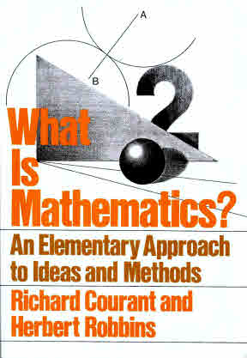

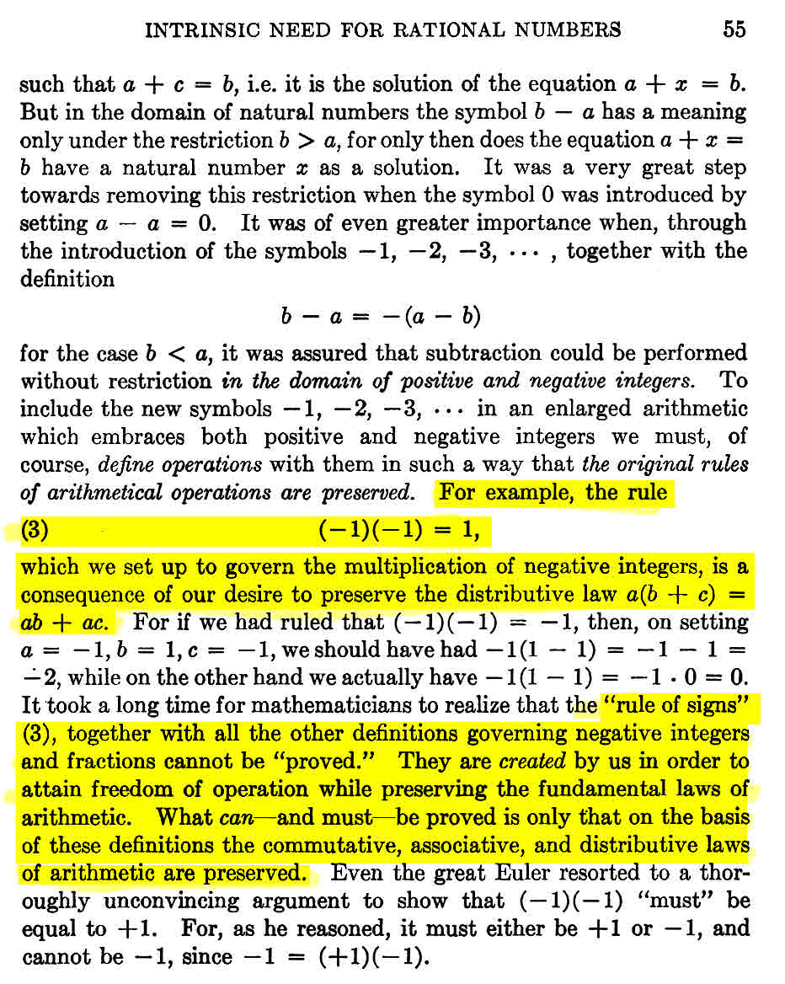*

SECTION-3: Breaking the Dash-Cross Codes of BS Math

Studying the dash-cross codes of BS math has allowed the breaking of the codes and the reasons for the errors in BS negative/positive math.

Code 1: Dash sign (-)

Math:

* (-) used as a subtraction operator
* (-) used as a direction in space; labeled negative (whatever that means)
* (-) used as an exponent to mean divide 
* (-) used to show the number of zeros to the right of a decimal point; 10-5=0.00001
* (-)(-) used to multiply dashes times dashes and change them into crosses
* (-)(+) used to multiply dashes times crosses and change them into dashes

Physics:

* (-)negative electron (whatever that means)
* (-)negative mass (whatever that means)

Chemistry:

* (-) thermochemistry; enthalpy, entropy and Gibbs free energy to determine the final sign associated with a spontaneous process

Code 2: Cross sign (+)

* (+) use as an addition operator
* (+) used as a direction in space; labeled positive (whatever that means)
* (+) used to show the number of zeros to the left of a decimal point; 10+5 = 100000
* (+)(-) used to multiply crosses times dashes and change them into dashes
* (+)(+) used to multiply crosses times crosses and leave them as crosses

Physics:

* (+) positive proton (whatever that means)
* (-) positive mass (whatever that means)

Chemistry:

* (+) thermochemistry; enthalpy, entropy and Gibbs free energy to determine the final sign associated with a spontaneous process

The same dash symbol (-) is used for **numerous different math operations**. The definitions established for the use of the dash symbol (-) do not distinguish between their different operations. In many math operations, the dash symbol is changed to mean one of the other two meanings. It is amazing that math has proceeded to its current level of use with this illogical use of a symbol.

The **same** cross symbol (+) is used for **numerous different math operations**. The definitions established for the use of the cross symbol (+) do not distinguish between their different operations. In many math operations, the cross symbol is changed to mean the other meaning.

**SYMMETRY BREAKING -** Because BS math uses the same symbol for different operations, they created a number line based on broken-symmetry. The negative (- dash) side of the BS number line produces different answers than the positive (+ cross) side of the BS number line.

* (-)(-)= (+) A symbol on the left side of the BS number line multiplied by the same symbol on the left side of the BS number line is moved to the right side of the BS number line and the (- dash) is changed to a (+ cross)**. Not just subtraction, but double subtraction! This produces broken symmetry.**
* (-)(+)= (-) A symbol (- dash) on the one side of the BS number line is multiplied by a symbol (+ cross) on the other side of the BS number line is equal to a symbol (- dash), only, on the left side of the BS number line. Again, a double subtraction! **This produces broken symmetry.**
* (+)(+)= (+) A symbol on the right side of the BS number line multiplied by the same symbol on the right side of the BS number line remains on the right side of the BS number line**. Symmetry is NOT broken. However multiplying symbols with different meanings is ILLOGICAL.**

SECTION-4:

Broken-Symmetry (BS) Math versus Symmetry-Math (SM)

BS Math System:

* Originated with broken-symmetry in the X, Y, Z plane.
* Originated with mirror-broken-symmetry in the X, Y plane.
* Created an illogical Rule-of-Signs that cannot be proved to preserve the distributive law.
  + (-)(-)=(+)
  + (+)(+)=(+)
  + (-)(+)=(-)
* Created imaginary numbers to compensate for broken-symmetry.
* Created absolute values to compensate for incorrect answers from the Rule-of-Signs and negative numbers.
* Produces broken symmetry graphs for  functions;
  + dash (-) side of graphs is different from the cross (+) side of graphs.

SM system:

* Returns symmetry to the X,Y,Z plane (removes the bilateral and mirror-broken-symmetry of the Cartesian coordinate system)
* Provides a logical Rule-of-Signs
  + 
* Removes BS error in the distributive law
* Removes imaginary numbers.
  + Which means that all math using imaginary math must be reformulated using SM:
    - Quantum mechanics
    - Schrodinger’s equation
* Removes absolute values
* Produces symmetrical graphs for  functions.
* Shows the math error in Einstein’s Special relativity.
  + One of Einstein’s math errors was due to the use of the BS math distributive law.
  + A second error was multiplying a direction to the left by a direction to the right.

**\***Named the **Cartesian** coordinate system after the [French](http://en.wikipedia.org/wiki/France) [mathematician](http://en.wikipedia.org/wiki/Mathematician) [René Descartes](http://en.wikipedia.org/wiki/Ren%C3%A9_Descartes). The idea of this system was developed in 1637 in two writings by Descartes and independently by Pierre de Fermat. BS was established before the age of science.

* 1610: In 1610 Galileo published an account of his telescopic observations of the moons of Jupiter, using this observation to argue in favor of the sun-centered world
* 1687: Newton: Philsosphiae Naturalis Principia Mathematica, published in 1687
* 1820: Faraday: electricity and magnetism

SECTION-5: Broken-Symmetry (BS) Math

Why a Negative Times a Negative does not equal a Positive

It took four year of study to discover why a only works in an imaginary world where space in the dash (-) direction is different from space in the cross (+) direction.

Started working on the problem in August of 2001; solved in January of 2005.

**January 7, 2005: Solutions found to BS math dash, cross codes.**

BS Math: Rule-of-Signs ILLOGICAL



In BS math no distinction is made between a subtraction operator and an addition operator and a direction in space. This is where the problem exists. Data points created using BS math produce graphs that are not symmetrical; dash side different from cross side (examples will be shown later). However, if a real problem's space data points follow the non-symmetrical graph, the graph can provide usable answers. This is why no one discovered the problem.

Symmetry-Math (SM):If we specify that the dash sign (-) means only subtraction and the cross sign (+) means only addition and an appropriate symbol is used for a direction in space, space becomes symmetrical. Math operators and directions in space are not the same and the same symbol should not be used to represent them. LOGICAL

|  |
| --- |
| BS Math: Illogical; The negative is not just subtracted, it is move by the same amount to the right side of the number line; double subtraction. |
| SM: Logical  The subtraction of a direction is equal to the opposite direction. The answers are correct using correct logic. There is NO multiplication of a subtraction operator by a direction in space. There is just the subtraction of a direction in space. If instead of labeling the left side of a coordinate system as a negative (-), the same as a subtraction operator, we label it with an arrow () to represent the direction. Then, a subtraction from that direction will be in the opposite direction (). This single subtraction; the direction arrow head returns to the zero point on the number line. |

|  |
| --- |
| BS Math:   * A negative (whatever that means) multiplied by a positive (whatever that means) is equal to a negative. This is illogical. * A subtraction operator multiplied by an addition operator is equal to a subtraction operator. This is illogical. * A direction to the left multiplied by a direction to the right is a direction to the left. This is illogical. * A dash multiplied by a cross is equal to a dash. This is illogical |
| SM: Logical  The subtraction of a direction is equal to the opposite direction. |

|  |
| --- |
| BS Math: What is the meaning of multiplying addition operators? They are separate math functions.  Illogical |
| SM: A number times a direction maintains the same direction.  Logical |

|  |
| --- |
| SM: The addition of a direction is in the same direction. There is no multiplication of addition operators. Logical |

For hundreds of years, BS math has obtained usable answers to certain equations. Math books need to be changed to eliminate the use of the cross sign (+) to represent something labeled a positive direction in space and the use of a dash sign (-) to represent something labeled a negative direction in space. Space does not have positive and negative directions.

SM use arrows for direction. All observers see the same direction:



Here is an example using SM:

What is the resultant direction and magnitude of the following arrows: 6 units in one direction and and 8 units in the opposite direction?



Using BS math:

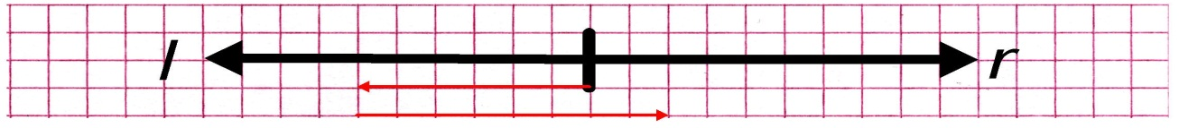

8r2*r*

6*l*



In BS:

* The first dash“-“in front of the six (-6) does not mean to subtract; it means six units to the left of zero.
* The second dash“-“between the 6 and the 8, does mean to subtract.
* The cross “+“in front of the 8 does not mean to add. It means a direction; go 8 units to the right of where the (-6) arrow stopped.
* BS math now multiplies a subtraction operator by a direction to the right and changes both symbols to something called a negative.
* BS math now multiplies a direction to the left by this negative symbol and changes it to a positive symbol.

Again, BS math may provide a usable answer, but it is ILLOGICAL.

**Section 6**

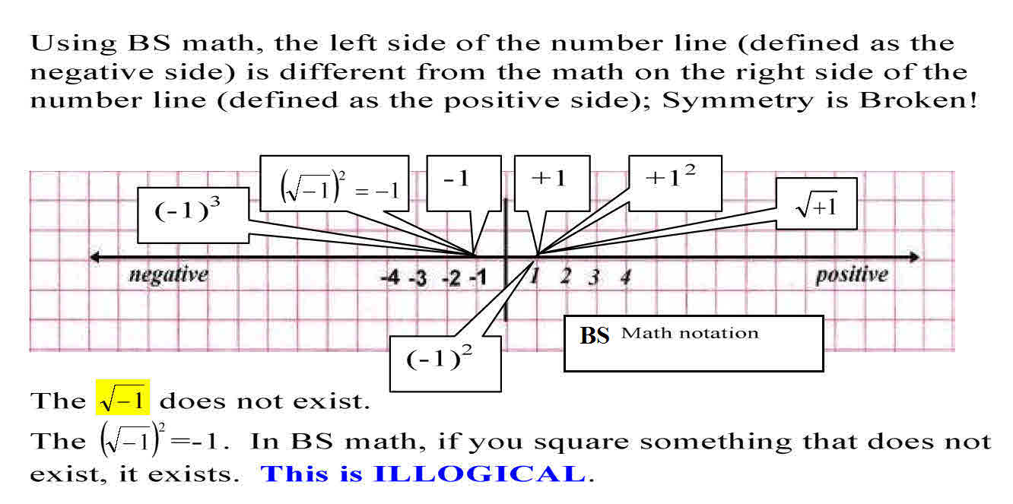

SECTION-7:

Negative and Positive Directions in Space

If I asked you to point to a negative direction in space, which way would you point? Hopefully, you will realize that there is no such thing as a negative direction in space.

If I asked you to point to a positive direction in space, which way would you point? Again, hopefully, you will realize that there is no such thing as a positive direction in space.

The Broken-Symmetry (BS) math number line is **broken-symmetry** in the x, y and z axis. BS math on the left, down, and back side of the BS math number line is different from the math on the right, up and front side of the BS math number line.

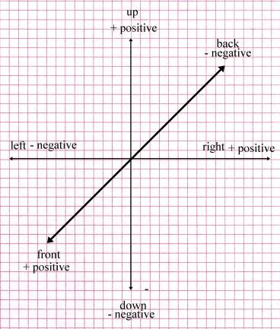

* Objects on the right of the x-axis are positive. (+)(+) = (+)
* Object on the left of the x-axis are negative. (-)(-) = (+); negative math is different from positive math. This is illogical
* Object on the top the y-axis are positive.
* Objects on the bottom of the y-axis are negative.
* Objects in the front of the z-axis are positive.
* Objects in the back of the z-axis are negative.

Again, BS math of the positive direction (x; right, y; up, and z; front) is different from the BS math of the negative direction (x; left, y; down and z; back).(Left & right), (front & back) and (up & down) axes have broken-symmetry.

In BS math, mirror image is broken symmetry in the x and z axis:

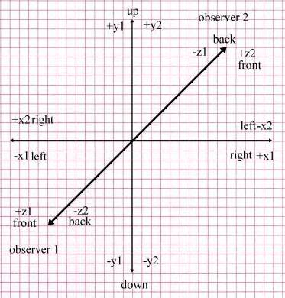

* If the left & right-axis are reversed, symmetry is broken. Obs-1 math is different from obs-2.
* If the front & back-axis is reversed, symmetry is broken. Obs-1 math is different from obs-2.
* If the top & bottom-axis are reversed, symmetry is not broken. Obs-1 math is the same as obs-2.

Negatives and Positives:

There are no negatives (-) in math or space directions. This was just a poor choice of words and symbols. There is nothing negative about space; it is just a direction. In math, the dash (-) symbol should only mean to subtract. It does not mean something is negative (whatever a negative means).

There are no positives (+) in math or space directions. In math, the cross (+) symbol should only mean addition. It does not mean something is positive (whatever a positive means).

When a direction arrow ““is used for the dash (-) symbol and the word negative is removed, the answers come out correctly for adding and subtracting directions in space. You do not need the invention of “i” (imaginary numbers)

|  |  |
| --- | --- |
| BS: Barry Mazur  Imagining Numbers  Page 145 | Symmetry-Math using arrows for direction |
|  |  |
|  |  |
|  |  |
| BS Math is Illogical | SM is logical |

A Subtraction of one direction in space means to move in the opposite direction.

|  |  |  |
| --- | --- | --- |
| This is NOT multiplication of a dash times an arrow | This is NOT multiplication of a dash times an arrow | SM: Logical  The subtraction of an arrow pointing in any direction is an arrow pointing in the opposite direction. |
| (dash)(dash)=(cross)  A negative (subtraction operator) multiplied by a negative (direction in space) = a positive direction in space  Illogical | (dash)(cross)=(dash)  A negative (subtraction operator) multiplied by a positive (direction in space) = a negative direction in space  Illogical | BS Math: Illogical |

Addition means to move in the same direction.

|  |  |  |
| --- | --- | --- |
| SM Logical | SM Logical | SM  Logical |
| an addition operator multiplied by a subtraction operator is equal to a subtraction operator. Multiplying subtraction and addition operators is illogical. | an addition operator multiplied by and addition operator is equal to an addition operator. Multiplying subtraction and addition operators is illogical. | BS: What is the meaning of multiplying addition and subtraction operator?  BS math is Illogical. |

|  |  |
| --- | --- |
|  | The resultant of arrows is the direction of arrow with the greatest magnitude Logical SM |
|  | The resultant of arrows is the direction of arrow with the greatest magnitude Logical SM |

Illogical and Incorrect BS math for the distributive law

|  |
| --- |
|  |
| If we substitute positive numbers into the equation, the answer will be correct. If (a = 5) and (b = 3) |
|  |
| When two positive numbers are added and squared, the BS math distributive law provides a correct answer. |

|  |
| --- |
|  |
| By definition, in BS math, no number squared can ever be negative. Therefore, no squared number can ever be an arrow moving in the dash (-) or negative direction if it is squared. In BS math, and addition operator multiplied by a subtraction operator is ALWAYS equal to a subtraction operator. If this had not been used for the last four hundred years, you would die laughing at the utter absurdity of the last statement. This is illogical and violates symmetry. |
| If a=5 and b=3 |
|  |
| As long as “a” is greater than “b”, the BS math distributive law provides correct answers. |

|  |
| --- |
| **BS breaks down when “b” is greater than “a”.** |
| If a=3 and b=5  BS math is illogical and incorrect. |
| By definition, the answer cannot be -4 in BS math. BS math produces incorrect answers. |
| This is where the distributive law provides incorrect answers. It produces an answer of +4 because by definition, no number squared in BS math can be a negative number. |
| Using incorrect BS math, the distributive law will give an incorrect answers of +4. This is incorrect and illogical. |

Since there can be no negative direction from a squared term in BS math, BS math must be revised. The BS math distributive law must be abandoned. All arrows inside brackets must be solved first. Then any number raised to any power will just be in the direction of the arrow. The reason BS math does not work is that it is multiplying an arrow going in one direction by an arrow going in another direction. Clearly this is not logical. The numbers 1,2,3,4 and –1,-2,-3,-4… need to abandoned. Arrows or some notation that is specific for a direction must be used.

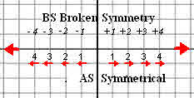

What does it mean to multiply  by ? Since multiplication is just addition. What would  time  be?



In SM Arrow/direction math, you cannot multiply arrows; going in opposite or the same directions.



The middle two terms are not logical. You cannot multiply opposite directions.

This is a MAJOR error in BS math. They multiply a dash [(-); a direction to the left] by a cross [(+); a direction to the right]. This is illogical and produces incorrect answers. The distributive law, when opposite direction are multiplied, produces incorrect answers.

SECTION-8: Symmetry Math (SM) 6.28o Circle

|  |  |
| --- | --- |
| C:\Users\Jack Kuykendall\Documents\SCIENCE\kuysg - CDs\a- AK Math 1st CD\S8- circle AK 6.28 deg changed 1-2010.jpgThe SM circle is based on 6.283185307 degrees | C:\Users\Jack Kuykendall\Documents\SCIENCE\kuysg - CDs\a- JK physics\Angular Motion.jpg |
| 1 | |  |  |  |  |  | | --- | --- | --- | --- | --- | |  | SM | sin | cos | tan | |  | 0.000000 | 0.0000 | 1.0000 | 0.0000 | |  | 0.010000 | 0.0100 | 1.0000 | 0.0100 | |  | 0.100000 | 0.0998 | 0.9950 | 0.1003 | |  | 0.200000 | 0.1986 | 0.9800 | 0.2027 | |  | 0.300000 | 0.2955 | 0.9553 | 0.3093 | |  | 0.400000 | 0.3894 | 0.9211 | 0.4228 | |  | 0.500000 | 0.4794 | 0.8776 | 0.5463 | |  | 0.600000 | 0.5646 | 0.8253 | 0.6841 | |  | 0.700000 | 0.6442 | 0.7648 | 0.8423 | |  | 0.800000 | 0.7174 | 0.6967 | 1.0296 | |  | 0.900000 | 0.7833 | 0.6216 | 1.2602 | |  | 1.000000 | 0.8415 | 0.5403 | 1.5574 | |  | 1.100000 | 0.8912 | 0.4536 | 1.9648 | |  | 1.200000 | 0.9320 | 0.3624 | 2.5722 | |  | 1.300000 | 0.9636 | 0.2675 | 3.6021 | |  | 1.400000 | 0.9854 | 0.1700 | 5.7979 | |  | 1.500000 | 0.9975 | 0.0707 | 14.1014 | |  | 1.570796 | 1.0000 | 0.0000 | 1/0 is undefined | |
| In SM, the sin of 1.57o is equal to 1. | |  |  | | --- | --- | | 3.141592654 | ❐ | | 6.283185307 |  | | 0.01745329252 | 1/57.29577951 | | x = *r* cos | cos =x/r | | y = r sin | sin = y/r | | y = x tan | tan = y/x | |  |  | |

Rotational Motion

One radian is an angle whose arc distance is equal to its radius.

 Circumference of a circle is equal to  times its radius.

 SM definition

 Broken-Symmetry (BS) Math definition



In SM, the sin of 1.57 degrees is equal to 1. In BSM, the sin of 90 degrees is equal to 1.



|  |  |  |
| --- | --- | --- |
|  | C:\Users\Jack Kuykendall\Documents\SCIENCE\kuysg - CDs\a- JK physics\Angular Motion.jpg |  |

* * = angle in radians (0 to 6.28 radians) (1o = 1 radian) and * * = angle in degrees

|  |  |  |  |  |  |  |
| --- | --- | --- | --- | --- | --- | --- |
|  | | | The average angular velocity of a body is the rate of its angular displacement. | | | |
|  | | | The instantaneous angular velocity is the limit of the ratio  as  approaches zero | | | |
|  | | | The average circumference velocity of the body is the rate of its distance traveled  divided by the time | | | |
|  |  | | | | | The equation of the relationship between the angular velocity and the velocity of a point on that body |
|  | | | | The average angular acceleration is the change in the angular velocity. | | |
|  | | | | The instantaneous angular acceleration is the limit of the ration of  as  approaches zero | | |
|  | |  | | | The equation of the relationship between the angular acceleration and the acceleration of a point on the body | |
|  | | If a body with an initial angular velocity  has a constant angular acceleration, it will turn through an angle  in a time ***t*** | | | | |

*The 360-degree circle is 4400 years old and extremely outdated.

**Q: Why does a circle have 360 degrees; why not 100 degrees? Also why is a degree 60 minutes and a minute 60 seconds? --HSR, Pakistan**

**A:** A probable answer. A line of ancient peoples (Sumerians, Akkadians, and Babylonians) who lived in Mesopotamia invented writing, observed the skies, and invented a 360-degree circle to describe their findings. About 3000 BC, the Sumerians invented writing. They also had a calendar, dating from 2400 BC, that divided the year into 12 months of 30 days each, that is, 360 days.

The Sumerians watched the Sun, Moon, and the five visible planets (Mercury, Venus, Mars, Jupiter, and Saturn), primarily for omens. They did not try to understand the motions physically. They did, however, notice the circular track of the Sun's annual path across the sky and knew that it took about 360 days to complete one year's circuit. Consequently, they divided the circular path into 360 degrees to track each day's passage of the Sun's whole journey. This probably happened about 2400 BC.

A 100-degree circle makes sense for base 10 people like us. But the base-60 Babylonians came up with 360o and we cling to their ways-4,400 years later.

SM will be using a circle with 6.283185307o.

Section-9

Broken-Symmetry (BS) Math invents Absolute Values for Displacement

Even for a simple displacement of a mass, BS math invented a definition and absolute values to obtain something labeled a positive number answer.

I----------I----------I----------I----------I----------I----------I----------I----------I

-4 -3 -2 -1 0 +1 +2 +3 +4

**a** >>>>>>>>>>>>>>>>>>>>>>>>>>>>>>>>>>>>>>>>**b**

**c**<<<<<<<<<<<<<<<<<<<<<<<<<<<**b**

If a mass starts at and moves to 

BS math provides a usable answer without a definition or absolute values:



However, If an object starts at 

BS math had to invent a definition of “absolute values” to provide a usable answer.

---------I----------I----------I----------I----------I----------I----------I----------

-4 -3 -2 -1 0 +1 +2 +3 +4

**a** >>>>>>>>>>>>>>>>>>>>>>>>>>>**b**

**c**<<<<<<<<<<<<<<<<<<<<<<<<<<<<<<<<<<<<<<<<<**b**

BS Math:

BS math makes up a definition that all displacements are positive. Since this example provides an answer with something labeled a negative, the positive definition must be applied and (-2) is changed to (+2). A definition is needed to arrive at a usable answer with BS math.

In SM, absolute values and a meaningless definition of “positive” are removed. In SM, mass and directions in space are defined by the direction and magnitude of the resultant of arrows.



With SM, you get total distance traveled by the object and the final direction of the displacement.

**SM**: 