Optics

Broken-Symmetry (BS) Math – Symmetry-Math (SM)
BS Optics by Eugene Hecht – SM Optics by Jack Kuykendall

Page 11: Masses Eugene Hecht’s Incorrect Postulates
- The essential feature of a particle is its localization; it exists in a well-defined “small” region of space. Correct
- Masses have a gravitational field and interact with each other. JK: what is a gravitational field?
- Real masses interact via fields, and, in a sense, the field is the particle and the particle is the field. Incorrect
- If light is a stream of masses (photons), they are by no means “ordinary” classical masses. Incorrect

Page 11: Waves
- The essential feature of a wave is its non-localization.
- A classical traveling wave is a self-sustaining disturbance of a medium, which moves through the medium transporting velocity relative to the medium.
- In the past century, we have found that the electromagnetic wave is not distributed continuously.

Page 11: 2.1 One-Dimensional Pulse
- An essential aspect of a pulse is that it is a self-sustaining disturbance of the medium through which it moves.
- Sound velocities are longitudinal – the medium is displaced in the direction of motion.

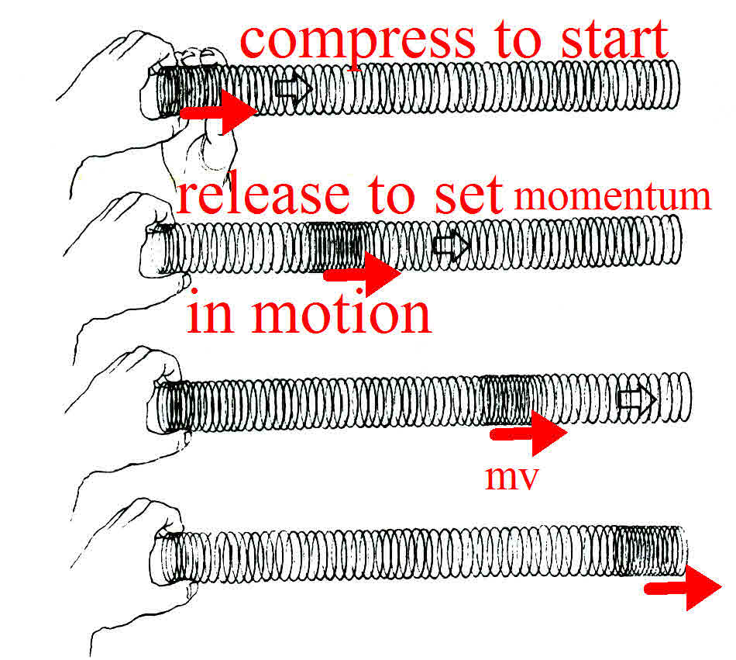

Velocity on a string is displaced in a direction perpendicular to that of the motion that creates the 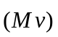.
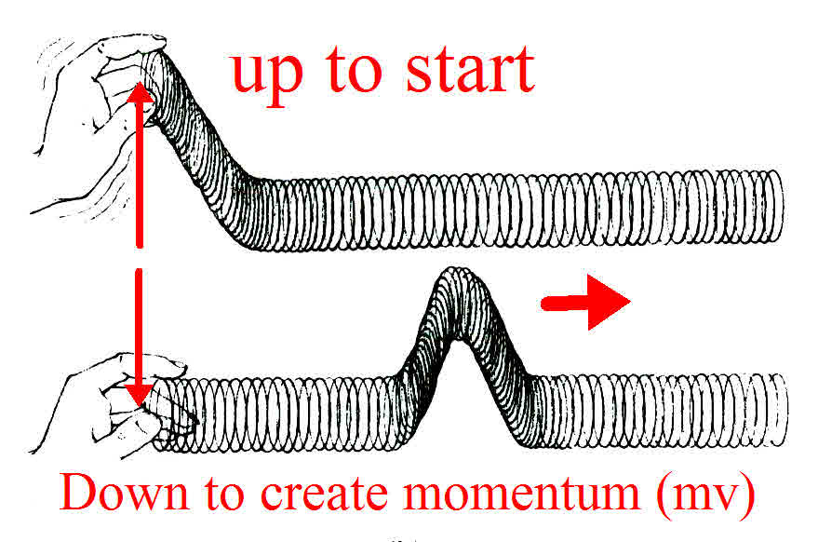
Page 11:
- Theadvances through the medium.
- The individual participating atoms remain in the vicinity of their equilibrium positions: theadvances, not the material medium.
- It is this property that allowsto move at high speeds.

Page 11
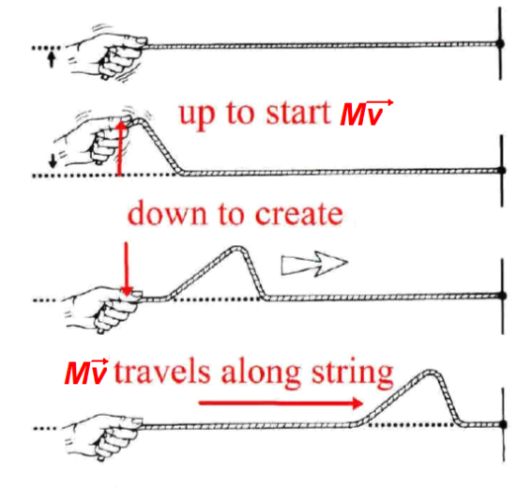

BS: Envision a wave moving on a string.
SM: Momentum moving in the direction of the arrow.

BS: Since the disturbance is moving, it must be a function of both position and time:
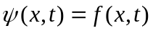 (2.1)

SM: 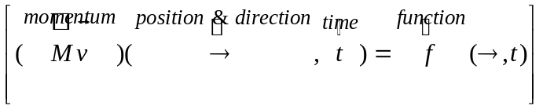

BS: The shape of a disturbance at any instant, say t = 0, can be found by holding time constant at that value.
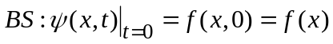 (2.2)

SM: Setting t = 0 is just a mathematical tool to see the shape of the wave. There is no time t = 0. Time can never equal 0. There are no stationary waves or masses in the universe. Movement or stationery is relative to other masses.
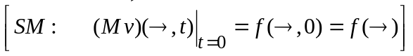

BS math: The top graph is a pulse traveling in the stationary coordinate system S at a speed v.  SM: The top graph is a momentum pulse traveling in a coordinate system where the observer at {0} is stationary relative to the pulse. Both the observer and pulse are always moving relative to other masses in the universe.  BS math & SM: The middle graph is the same wave as seen by an observer traveling with the momentum at the same velocity.  The bottom graph creates an artificial coordinate system so that an observer at {0} will see the same thing as an observer traveling with the momentum shape just offset by the distance (vt) from {0}. | 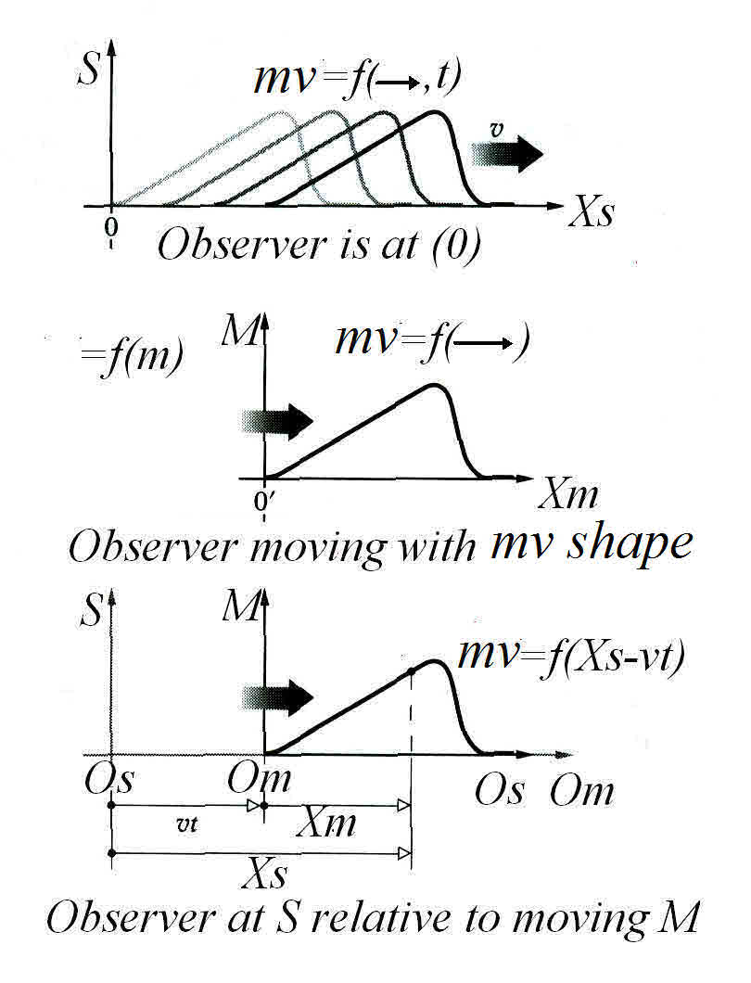

Page 11&12: JK: This section is out of place in the book and only adds confusion at this point.
BS: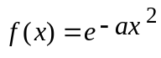, where a is a constant, the profile has the shape of a bell; that is, it is a Gaussian function. (Squaring the x makes it symmetrical around the x = 0 axis.)

SM: This is a major departure between BS negative/positive math and SM. You do not need to square terms in SM math to achieve symmetry. In SM, the dash (-) sign is NEVER used to change from itself to a number dividing one by itself. In SM math, the following is the only notation used: 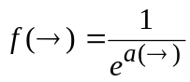

Page 12: After a time (t), the pulse has moved along the x-axis a distance (vt). We now introduce a coordinate system (S’), that travels along with the pulse at the speed (v). In this system 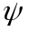 is no longer a function of time.
BS math 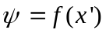 (2.3)
SM 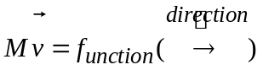

The disturbance looks the same at any value of t in S’ as it did at t = 0 when S and S’ had a common origin.

We now want to rewrite Equation (2.3) in terms of x to get the pulse as it would be described by someone at rest in S.

BS math 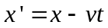 (2.4)
SM 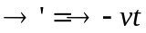

Substituting (2.4) into (2.3) BS math 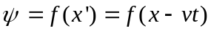 (2.5)
SM 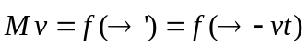

BS math: This represents the most general form of the one-dimensional wave function. We choose a shape and substitute 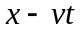 for in f(x). The resulting expression describes a wave having the desired profile, moving in the positive -direction with a speed v.

SM: This represents the most general form of the one-dimensional momentum pulse. We choose a shape and substitute 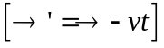 for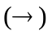 in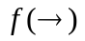. The resulting expression describes a 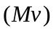pulse having the desired profile, moving in the direction of the arrow with a velocity 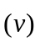.

Page 12: To see how all this works in detail, let’s perform an analysis for a specific pulse.

In BS math, the equation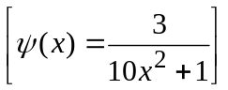, must use a square term in order to make the curve symmetric. This is a major fault of BS negative/positive math.
In SM math, when t is set to “0”, 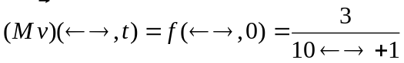
NO SQUARE TERM IS NECESSARY

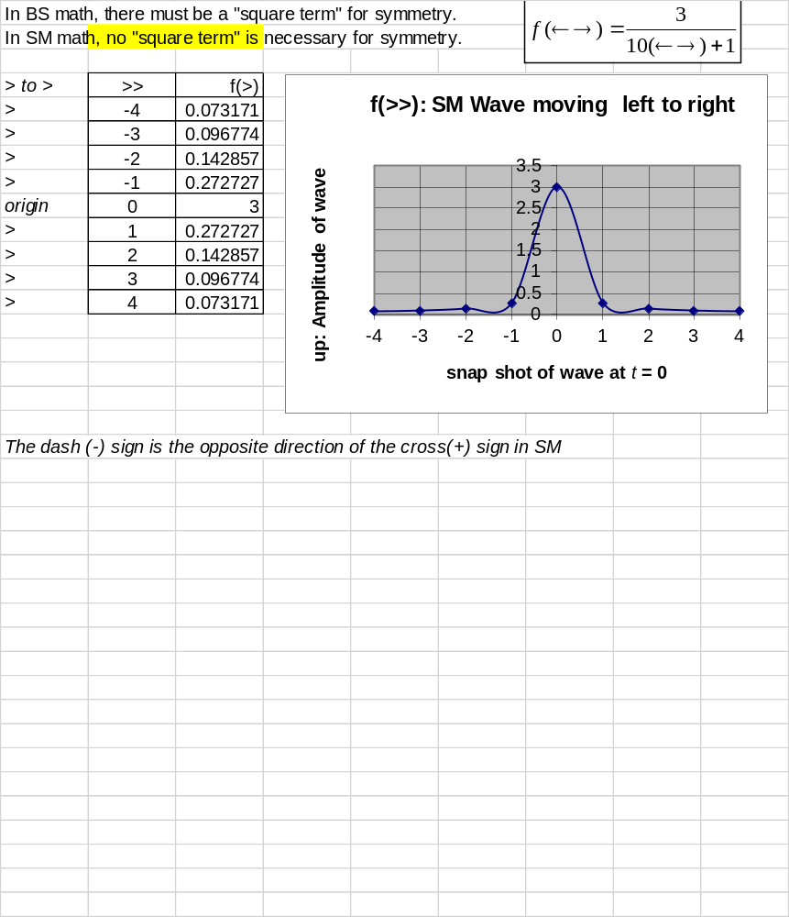

Page 12: SM and graphs show a wave moving in the direction of an arrow. There is no need for a BS math squared term to get rid of a negative sign and broken-symmetry. In SM, there is also no need to change from a subtraction operator to an addition operator when you change direction.

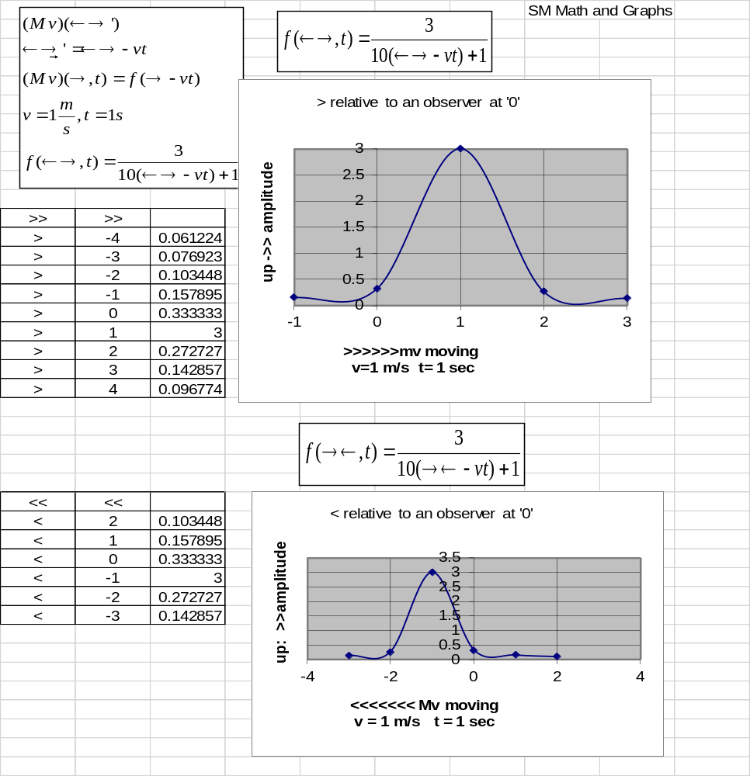

The following is the unnecessary and very complex treatment of a moving wave using BS math and physics.
Page 12&13: Complex BS math of a moving wave.

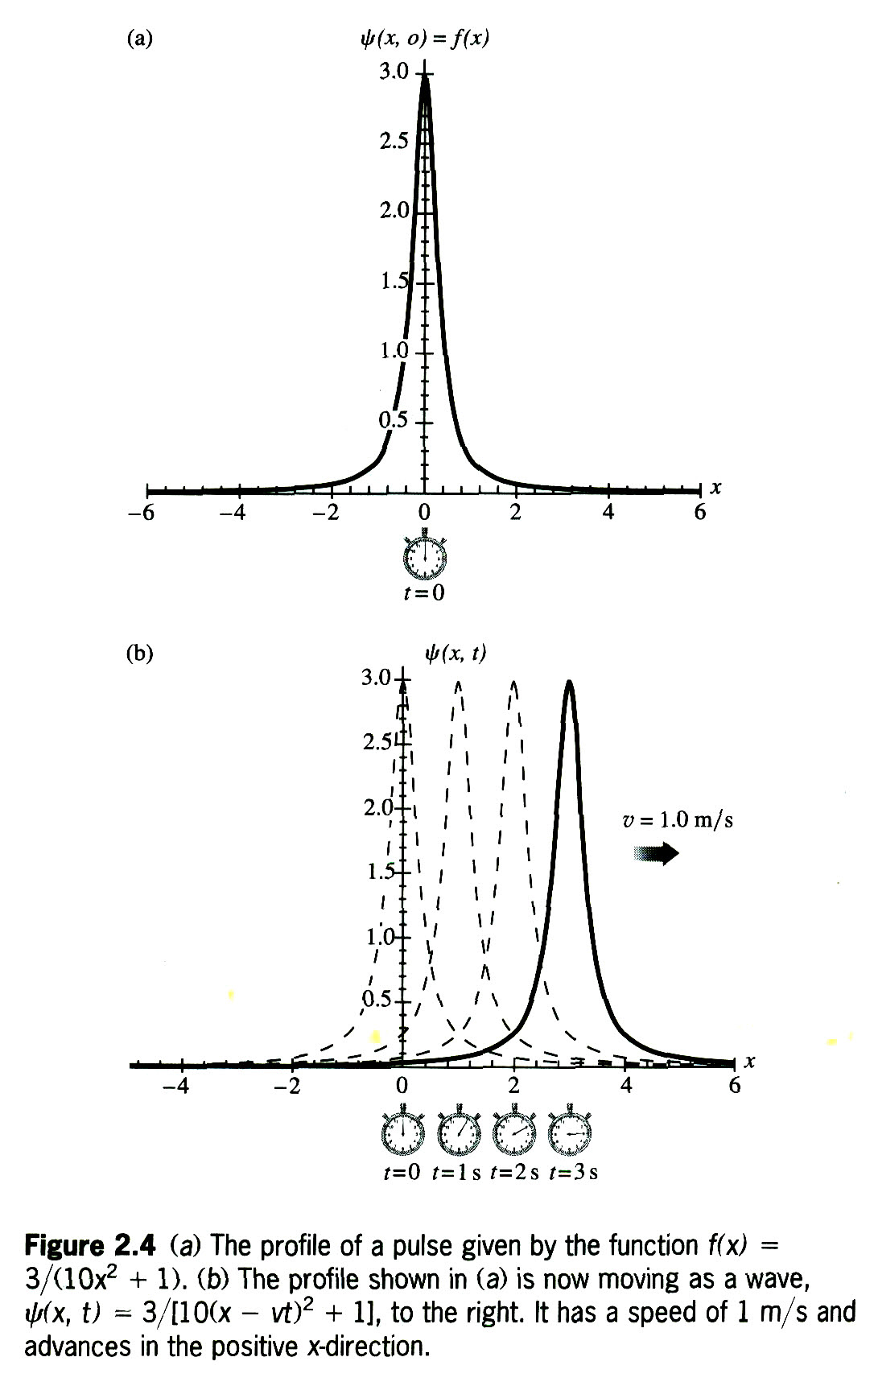
To see how this works with BS math, the pulse 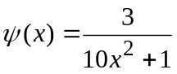 is plotted in Figure 2.4a & b. 2.4 a is when t = 0. 2.4b is when the pulse is moving to the positive side of the number line. For the moving line,
we replace x in f(x) with (x-vt), yielding, 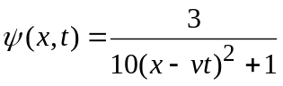. If v is set = 1 m/s and the function is plotted at t=0, t=1, t=2 and t=3 seconds, we get Figure 2.4b. This shows the pulse moving to the right at 1 m/s.

If we substitute (x + vt) for x in the profile function, the resulting wave would move to the left.

If we check the form of Eq. (2.5) by examining after an increase in time of and a corresponding increase of 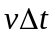in x, we find

and the profile is unaltered.

Similarly, if the wave was traveling in the negative x-direction, that is, to the left, Eq (2.5) would become

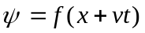, with v > 0 (2.6)

We may conclude therefore that, regardless of the shape of the disturbance, the variables x and t must appear in the function as a unit, that is, as a single variable in the form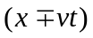.

Equation 2.5 is often expressed equivalently as some function of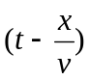, since
(2.7)

The pulse shown in Fig 2.2 and the disturbance described by Eq. (2.5) are spoken of as one-dimensional because the waves sweep over points lying on a line - it takes only one space variable to specify them. Don’t be confused by the fact that in this particular case the rope happens to rise up into a second dimension. In contrast, a two-dimensional wave propagates out across a surface, like the ripple on a pond, and can be describe by two space variables.

JK NOTES:
- BS math must use a square term to produce symmetry.
- BS math must change a subtraction sign to an addition sign to change directions.
None of this is necessary with SM math.

Page 20: 2.4 The Superposition Principle (BS interpretation)

When two separate waves arrive at the same place in space wherein, they overlap, they will simply add to (or subtract from) one another without permanently destroying or disrupting either wave. The resulting disturbance at each point in the region of overlap is the algebraic sum of the individual constituent waves at that location.
Once having passed through the region where the two waves coexist, each will move out and away unaffected by the encounter.

Page 20: 2.4 The Superposition Principle (SM interpretation)

When two separate pulses arrive at the same place in space wherein they overlap, they will simply add to (or subtract from) one another without permanently destroying or disrupting either pulse. The resulting disturbance at each point in the region of overlap is the algebraic sum of the individual constituent pulses at that location.
Once having passed through the region where the two pulses coexist, each will move out and away unaffected by the encounter

