Myth of the Two-Lever System

Theory: The Golf Swing is a 2-Lever System
Sources:
- Search For The Perfect Swing (5 British physicists)
- The Physics of Golf; Jorgensen

THE SEARCH FOR THE PERFECT SWING and THE PHYSICS OF GOLF both use a two-lever system as the model.
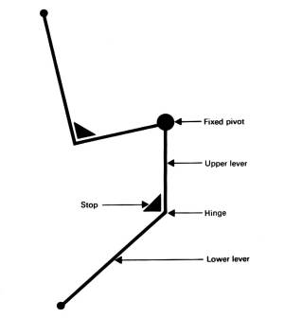
Simple observation of golfers and experiments show the model to be incorrect and therefore it should be abandoned as a model.
- It does not represent a real golfer with a two fulcrum grip
  - left hand bottom fulcrum, right hand top fulcrum
- It does not and cannot address muscular contraction for the left and right sides of the body.
- It does not allow for one of the major source of producing clubhead speed; the right are levers and trailing hand and wrist fulcrum.
- It assumes a freewheeling flail system for producing clubhead speed. The myth of the flail section shows this to be false.
- THE SEARCH FOR THE PERFECT SWING authors even claim that centrifugal force exists and is the principle that produces clubhead speed.

This is almost unbelievable coming from scientist. In THE SEARCH FOR THE PERFECT SWING, the authors state on page14, "Just because of the need for simplicity the scientist does not expect the model to represent every feature of the original system being studied; and because of this may in time have to be modified, or even replaced."
It is now time to abandon this model because it does not represent a golfer and is an inadequate representation of a golf stroke!

A 9-Lever System – By Jack Kuykendall

THE 9-LEVER MODEL

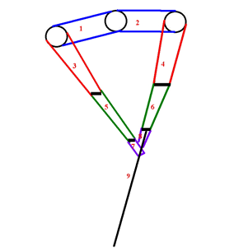

The correct model for a golfer is nine levers. They are:
• Left shoulder and right shoulder = 2 levers
• Left upper arm and right upper arm = 2 levers
• Left forearm and right forearm = 2 levers
• Left hand and right hand = 2 levers
• The shaft is a lever = 1 lever
• TOTAL = 9 LEVERS
The hips, legs and rotary motion of the body contribute so little to clubhead speed that they can be ignored.
The physics equation for torque is:
What this means is that you want the longest lever you can get and apply the maximum force if you want the greatest torque.

Bend the Left Arm to increase clubhead speed:
When the left arm bends through 90⁰ at the left elbow and only bends between 10º and 15º between the left forearm and the shaft, the powerful left triceps are moving a lever the length of the left forearm and the shaft.
This provides for the longest lever with the most force to move it.

Bending of the right arm to create clubhead speed:
At the top of the backstroke, when the right arm bends as much as possible and the right wrist extends (cocks) as much as possible, you have TWO powerful levers (the right triceps and the right forearm) moving 3 levers (the right forearm, the right hand and the shaft) like a bullwhip.
Because the right hand fulcrum is below the left hand fulcrum, it is the only one in the correct mechanical position to apply force at the 0.05 seconds before impact position.
The left hand fulcrum would have to move backwards to be the primary power source. Since this NEVER happens, the right arm and hand lever system ARE the primary source for producing clubhead speed.
The right arm provides and controls the major force in the golf stroke.

