Bryson DeChambeau

I have had numerous requests to analysis Bryson DeChambeau’s swing. The hype on TV and the internet about him being Moe Norman like is just that, hype. The hype of swinging on close to single plane (with hands high at address) is hyped as a superior method. Some are even comparing his mechanics to Moe Norman’s.

Moe did not swing on a single plane. Moe took the club straight inside, lifted it across the plane line, sat down into his knees a few inches at the start of the downstroke and stayed there until after impact; his left knee was directly over his left big toe and still bent into his sit down position.

DeChambeau’s mechanics are very good, but it is just another version of a traditional golf stroke with his hand high at address. It is basically Nancy Lopez.

These photos are from a company promoting the golf mechanics of high hands at address. It, obviously, worked extremely well for Nancy!

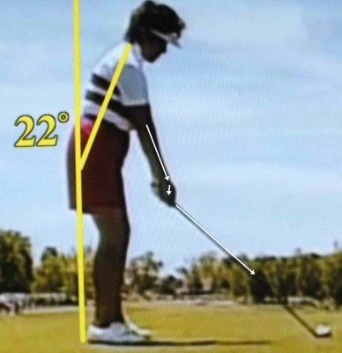 | 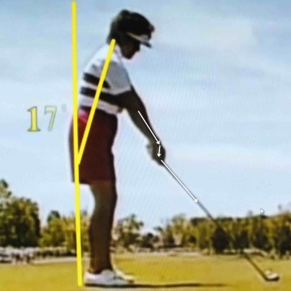 | 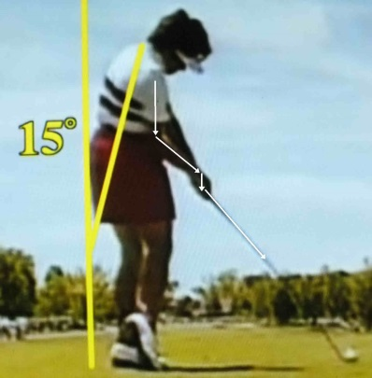
Normal Address position | Hands high address position | Impact

It may work just as well for Bryson. However, it will not be the mechanics that makes Bryson into a winner on the PGA tour. It will be his work ethics.

These photos were from an earlier time taken from the internet of a real stroke during an amateur golf tournament.
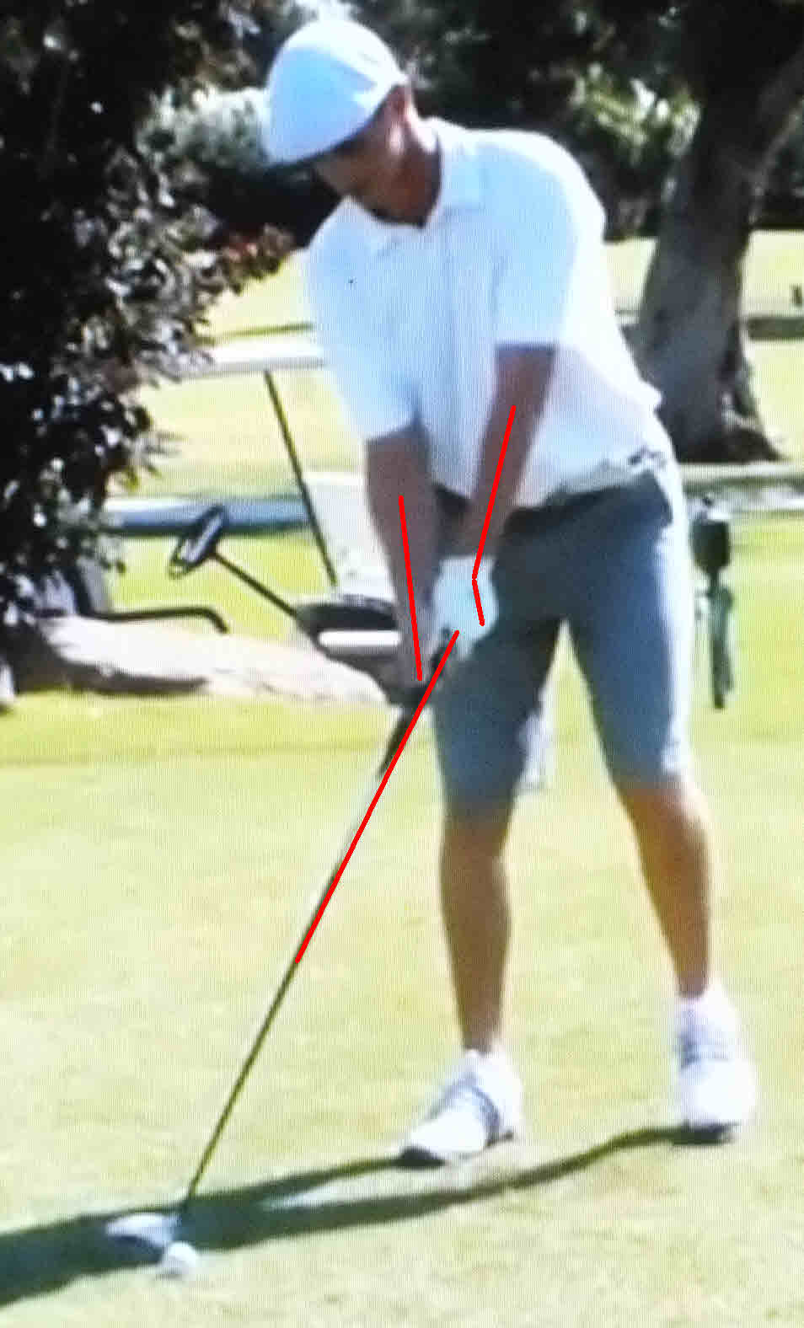 | 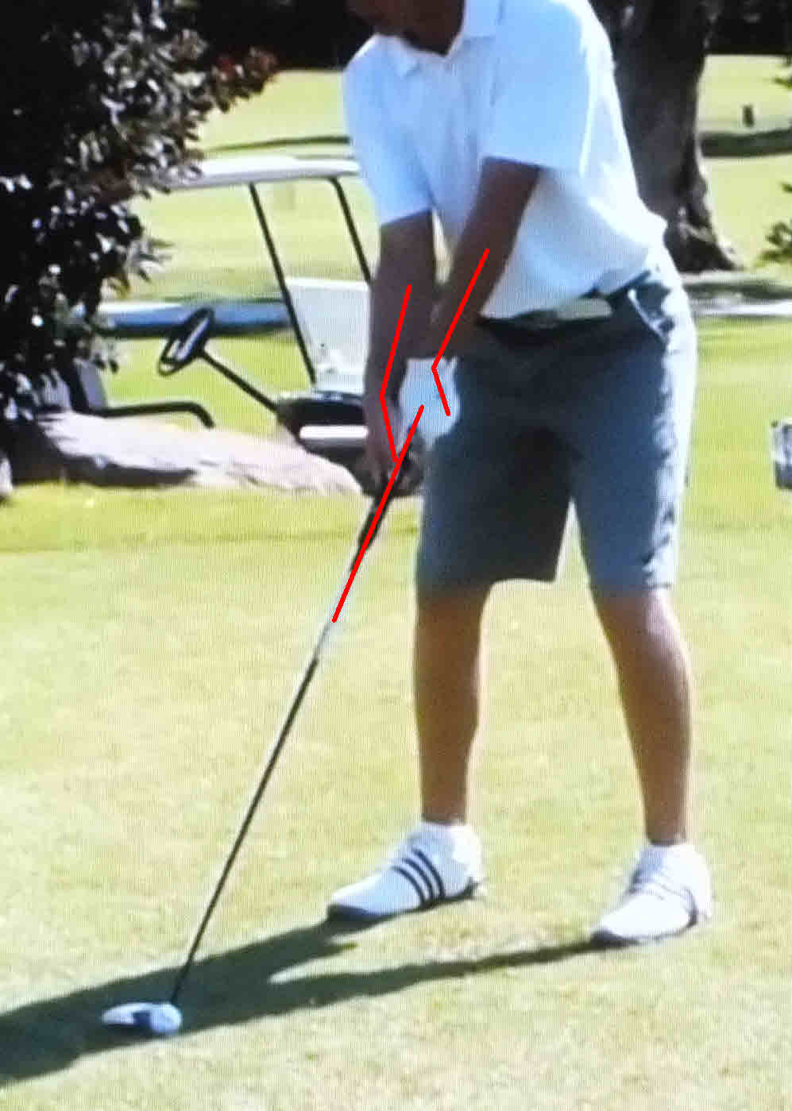
He starts out with the typical two-axis four lever set up. | He then raises his hand to an upright starting position. He is not Single-Axis. He has the traditional two-axis four-lever set up with high hands.

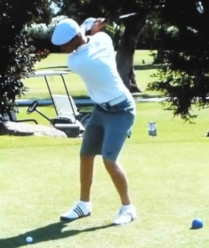 | 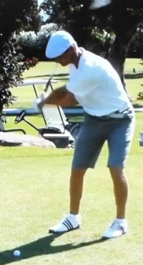 | 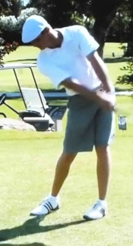 | 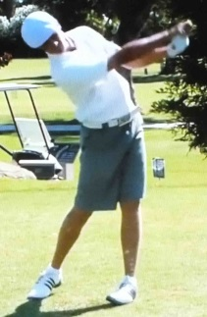
Traditional Top | Traditional downstroke | Traditional straighten of the legs through impact | Traditional rolling of the wrist after impact.

Again, this is a traditional stroke with high hands at address.

Kirk Junge is one of the Moe Norman sham & charlatan teachers claiming to teach Moe’s mechanics. The following photos are Junge’s YouTube presentation trying to convince golfers that Bryson is Moe Norman like. There is NO similarity between Bryson’s and Moe’s mechanics.
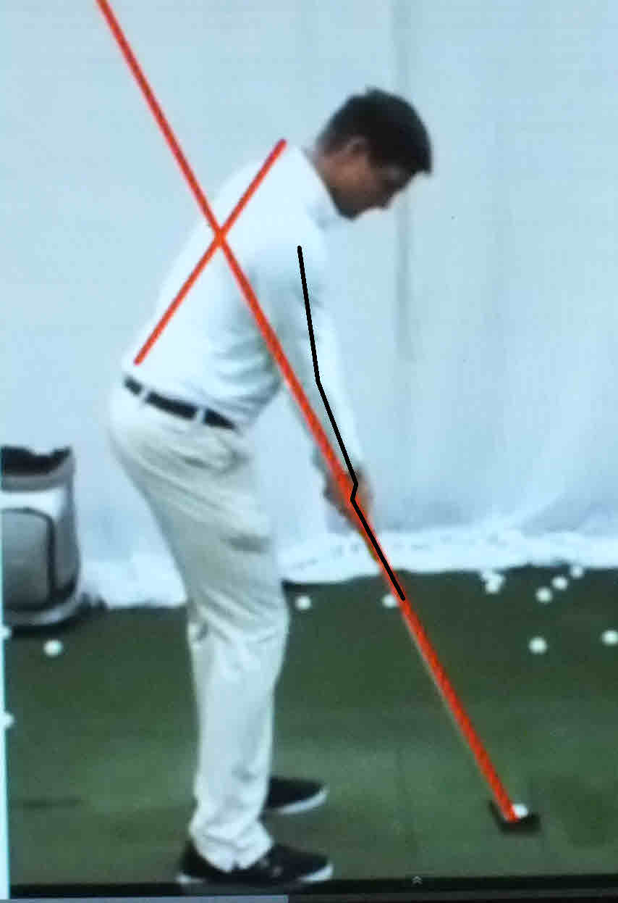 | Black Lines show two-axis four-lever right arm set up. Bryson just has his hands set high.
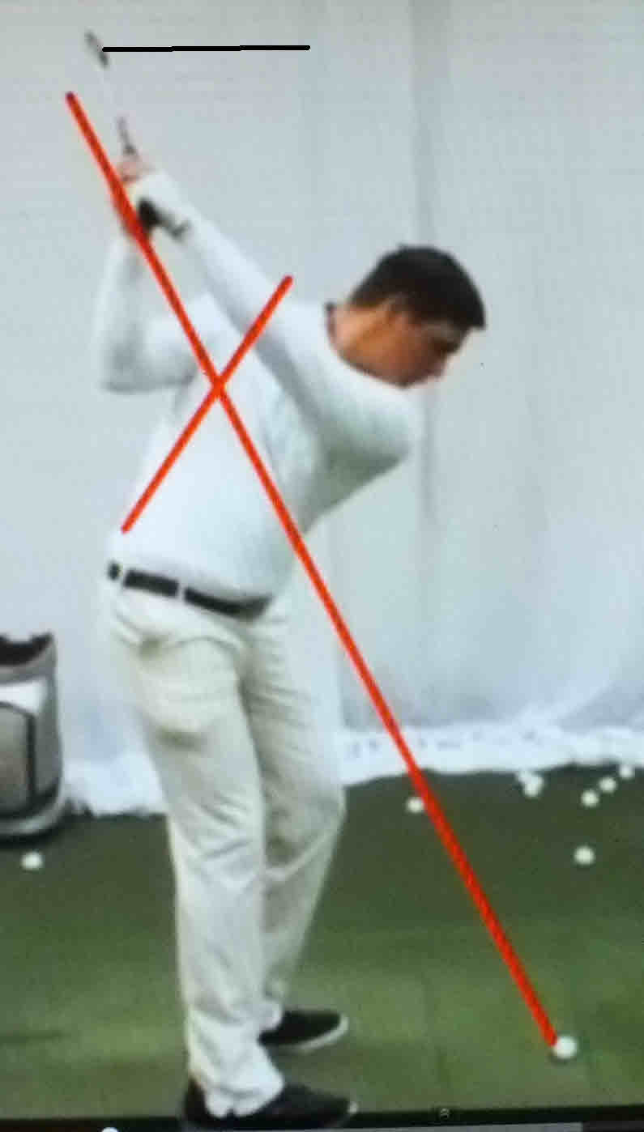 | Traditional top of the backstroke with forearm rotation. Observe that the butt of the grip is 90 degrees to the palm of the left hand at the top of the stroke.  It is not in his life line as shown in this fake grip pose.  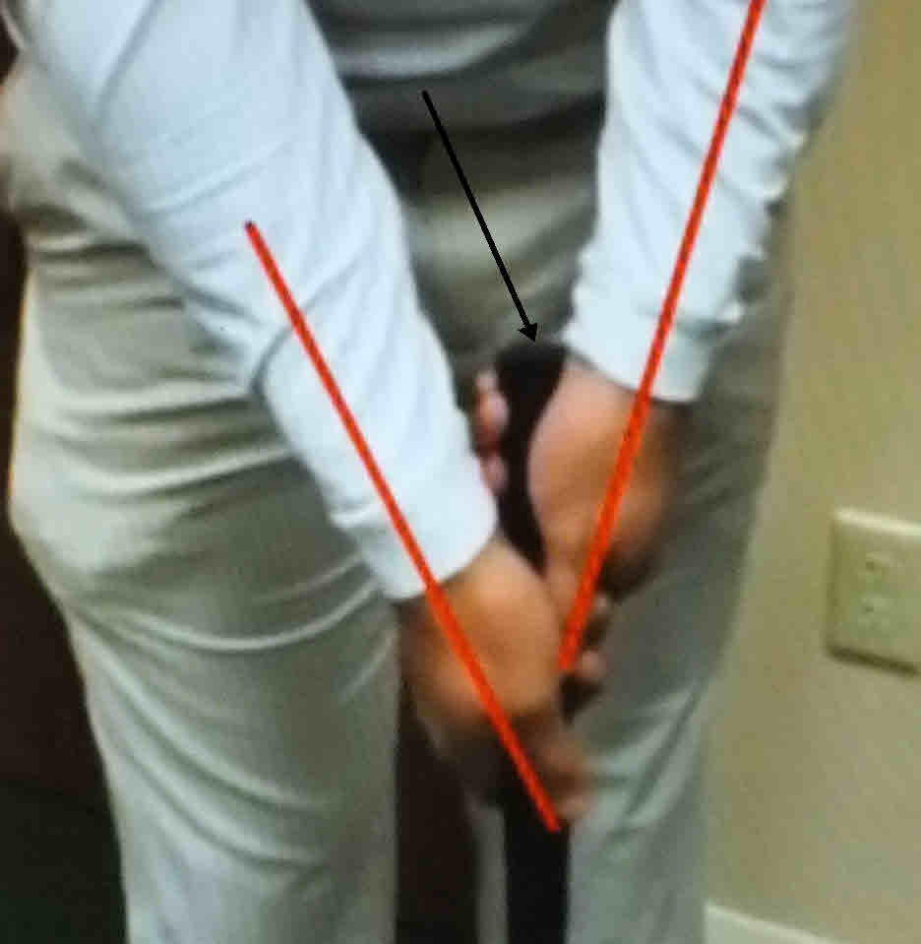
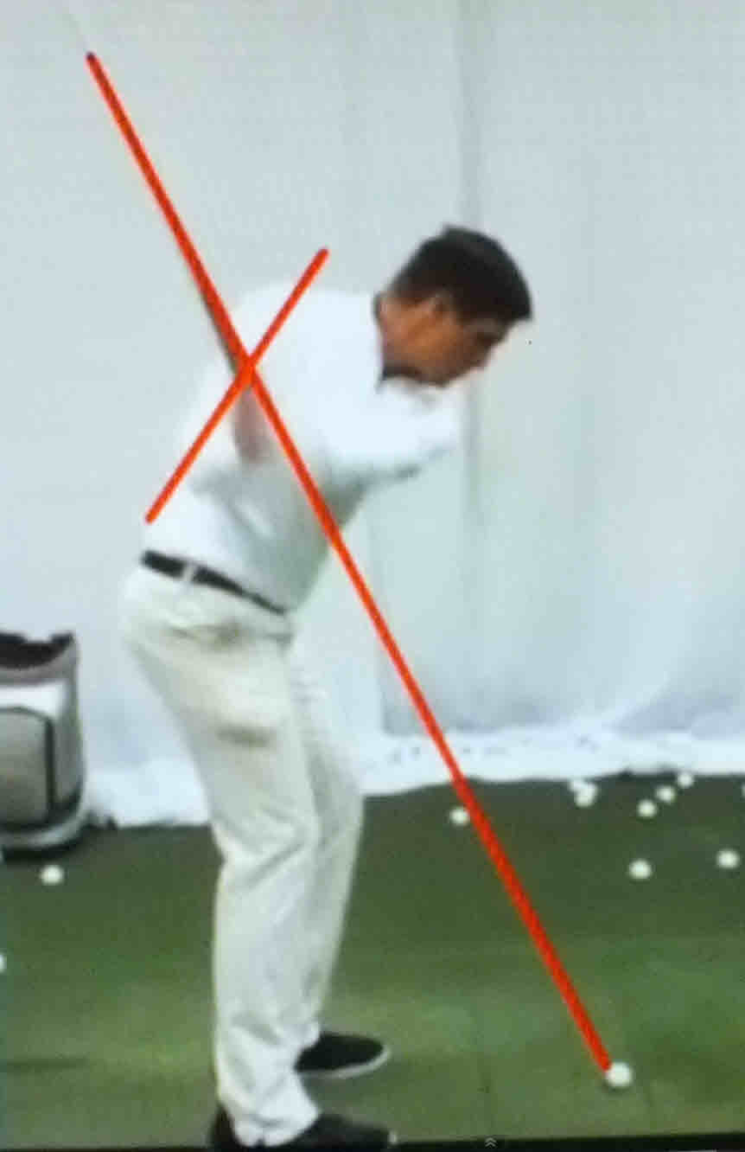 | Typical traditional downstroke. Hands move back and down while setting into the knees.
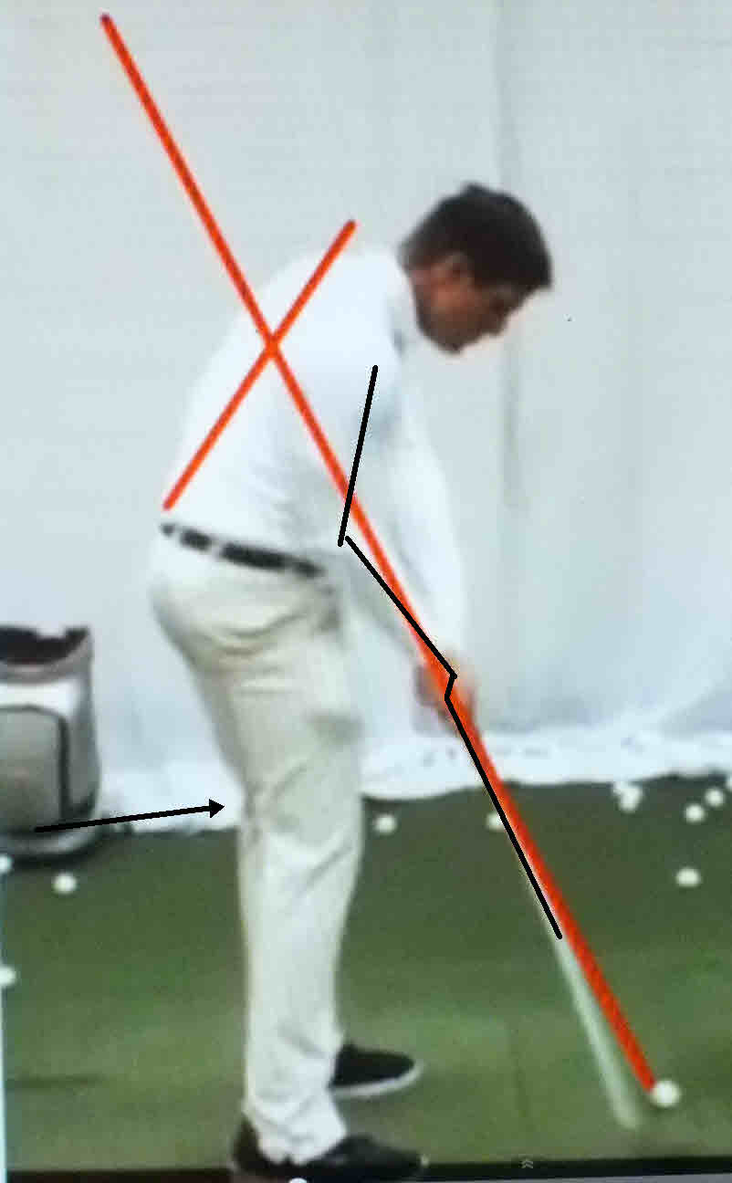 | Traditional two-axis four-lever right arm position at impact. Left leg is straightening and body is moving upward and backward.
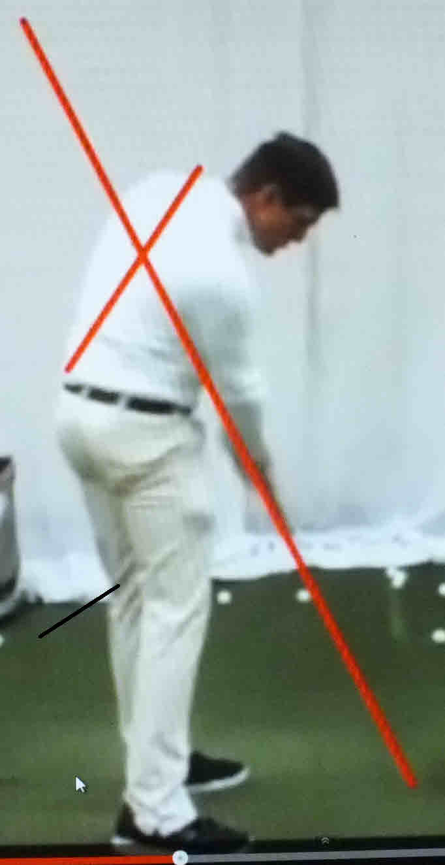 | Legs fully straightened and forearms fully rotating through impact.  Traditional after impact position.
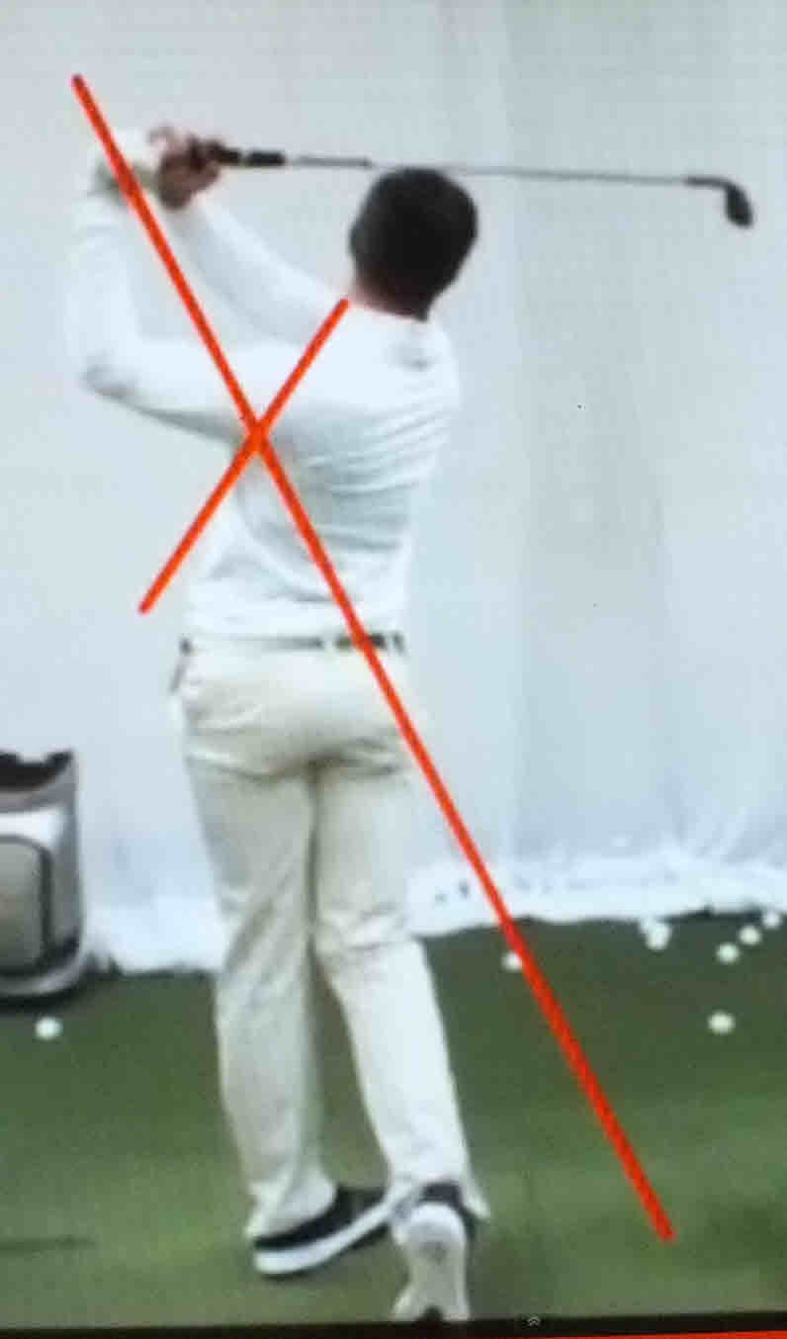 | Traditional finish.  Moe called this swinging around the golf course.  Moe’s clubhead always stayed inside the golf course.

I am certain Bryson will have an excellent golfing career. However, it will not be because of any superior mechanics. Again, it will be due to his work ethics.

