Sam Snead – Excellent Fundamentals for Traditional Mechanics
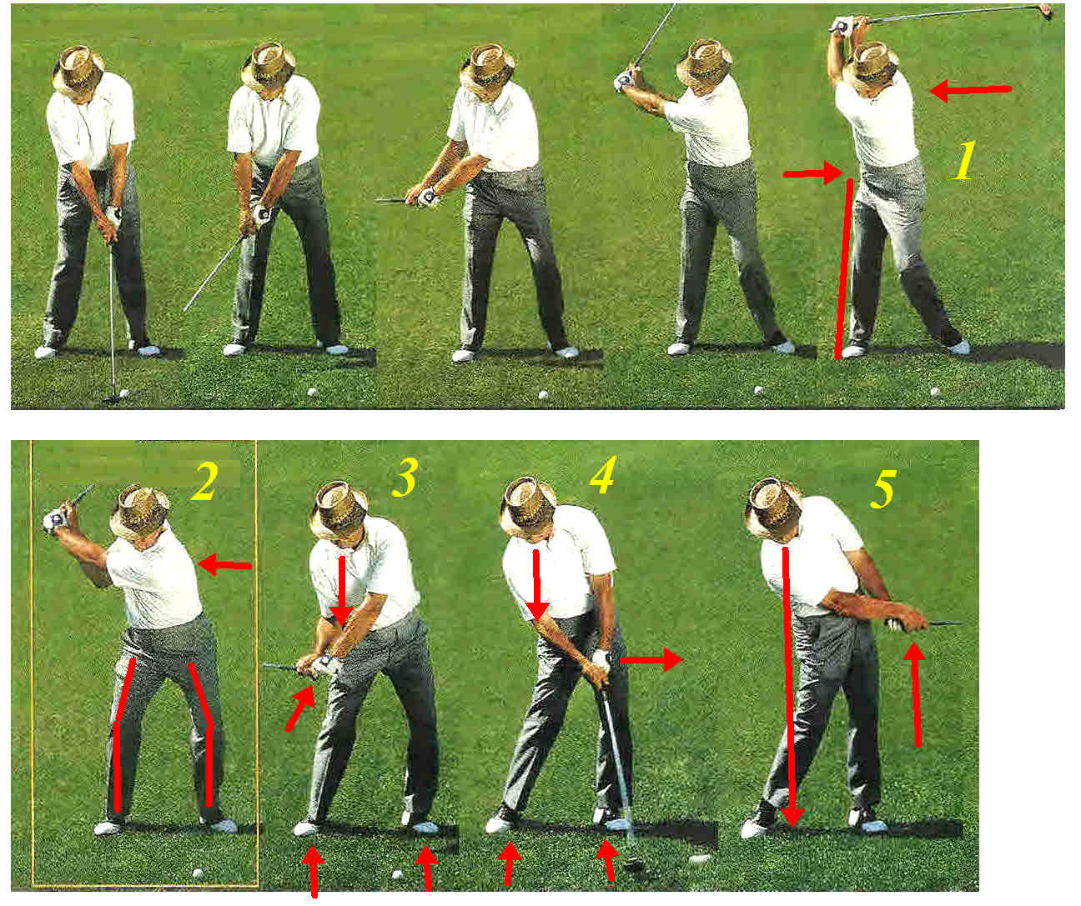

From the Top of the Backstroke through Impact and Release:
Photo 1:
- Sam is braced into his right leg.
- His back is pointed away from the target
- His hips are pointed away from the target; no torqueing the hips to the shoulders.
- His hands are at comfortable height at the top.
- His left arm is slightly bent; no straight left arm
Photo 2:
- Sam’s sit down move makes everything that follows just a reaction.
  - When you sit down, the shoulder and arms keep virtually the same relationship to the shoulders
  - The back remains facing away from the target.
  - His feet are flat on the ground; optimum stability
  - The hands set into a “slot” that prepares the right triceps and wrist to produce high clubhead speed.
Photo 3:
- His feet are still flat on the ground.
- His head is still over his right knee.
- His left knee is directly over his left big toe.
- Sam’s right triceps have moved his hands away from his right shoulder; this is a clubhead speed producer
Photo 4:
- Waist high in the downstroke to impact: Sam’s right triceps continue extending the right forearm and just before impact, the right wrist stretch reflex activates; producing Sam’s extremely high clubhead speed.
- His feet have not changed their orientation from photo-2; right heel has risen slightly.
- The back of his left hand faces the target line
- His head is still over his right knee.
Photo 5:
- Right hand continue to rotate into release
- His head is still in the same position.
- His feet have not changed their orientation from photo-2; right heel has risen slightly higher.

This mechanics was sound enough to compile the number one ranking for most wins:
Rank | Name | Birth | Died | Wins | Majors | Played | Span
1 | Snead, Sam | 1912 | 2002 | 82 | 7 | 1936-1965 | 30 yrs

If you plan to stay with traditional mechanics, you could never go wrong by copying Sam Snead’s mechanics.

