Professor P.M. Kanarev’s Electron Model and Theory

Jack Kuykendall English Translation and Rewrite with his interpretation of Professor Kanarev’s Theories.

Professor Kanarev’s model is based on the electron being a torus. The basic principle that governs an electrons behavior is the conservation of angular momentum (COAM).

|  |  |
| --- | --- |
| C:\Users\Jack Kuykendall\Documents\SCIENCE\JK physics\electron\Electron Torus.jpgTorus | COAM |

I will be using Symmetry-Math (SM); developed by Jack Kuykendall in 2005.

* SM for angular velocity: (Appendix-1).
* SM for COAM: (Appendix-2).
* SM for a torus: (Appendix-3).

Energy does not exist. Since Energy does not exist, it cannot convert to mass. The only thing that exists is the mass-in-motion relative to other mass-in-motion. Anything that is measurable has mass. Photons have mass. Photons have been experimentally shown to be able to convert their mass into the mass of electrons and positrons. Photon with enough mass can convert to any mass with a lower mass.



Professor Kanarev predicts that an electron is a torus that spins on two axes; one around the torus axis and one around the torus ring

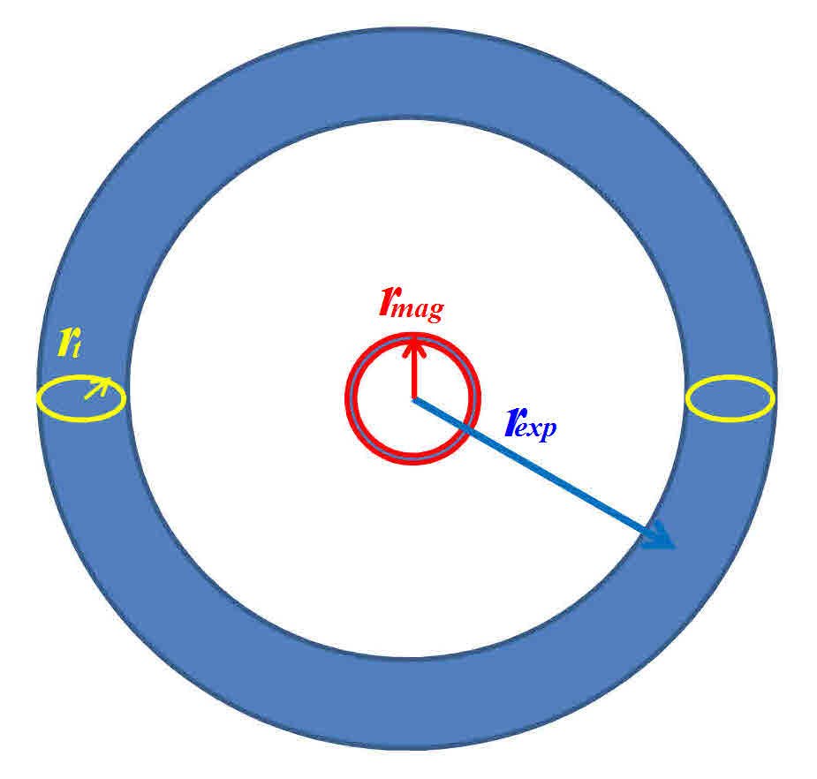

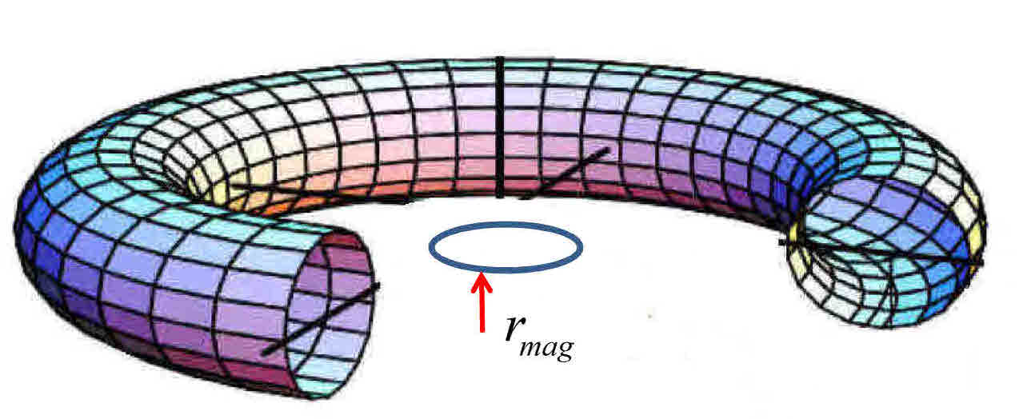Electron Torus Model

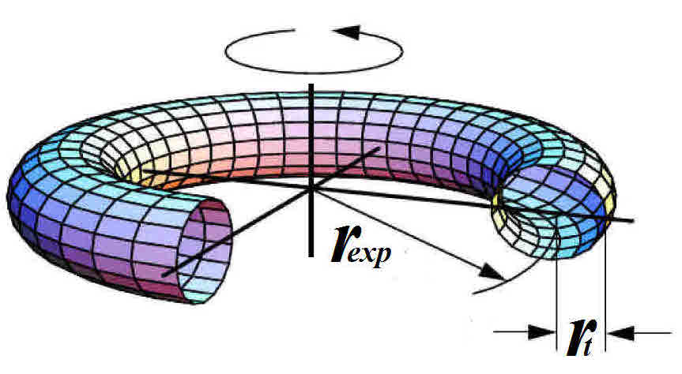

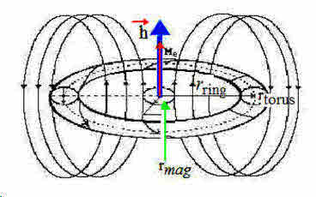







Chapter 8: 10th Edition of Kanarev’s Theories of the Electron, Proton and Neutron

(Jack Kuykendall's Rewrite)

Electron: A torus that rotates counter clockwise

|  |  |
| --- | --- |
| electrons spin counter clockwise | protons spin clockwise |

|  |  |  |  |
| --- | --- | --- | --- |
| z - (electron) Me & h left (2) Acep  Rmep | z - (proton) Mp right h left (2)  Rcpp  Ampp | z - (proton) Mp right h left (2)  Rcpp  Ampp | z - (electron) Me & h left (2) Acep  Rmep |

|  |  |
| --- | --- |
|  |  |
|  |  |

Codata 20118



Magnetic arrow strength versus Charge arrow strength:

* Since electrons repulse electrons, the Attractive Magnetic arrows must be stronger than the Repulsive charges between electrons.
* Since protons repulse protons, the Attractive Magnetic arrows must be stronger than the Repulsive charges between protons..
* Since protons attract electrons, the Repulsive Magnetic arrows must be stronger than the Attractive charge between protons and electrons.

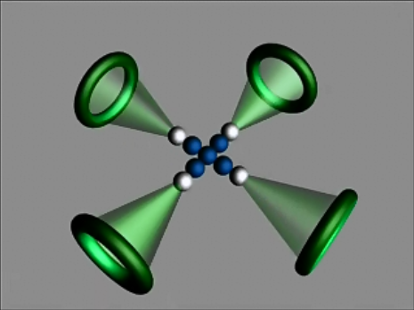

**Beryllium:**

* **Green is electrons**
* **White is protons**
* **Blue is neutrons**

**8. ELECTRONS, PROTONS, NEUTRONS**

**SECTION-8.1 Electron Model**

Kanarev's photon theory is based on the angular momentum of a rotating ring; Planck's constant. This same theory works for the electron and proton. The angular momentum of elementary particles shows that the wavelength  is equal to the radius  of their rotation.

 (142)

Planck's constant  is:

 (143)

For a photon,  (144)

Planck's constant  is the angular momentumof the electron. An electron will be shown to be a torus with rotation around two axis; the.

Starting with a ring model, math that describes the motion of electrons, protons and neutrons will be developed. The rotating ring model is shown in (Fig-37). The arrow is directed along the axis of rotation of the ring. For an electron, the rotation direction is counter-clockwise when viewed from the head of the arrows. is the spin of the electron.

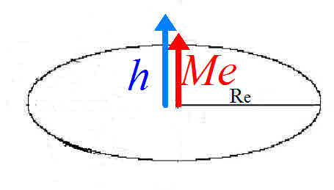

Fig-37: The angular momentum of a ring

Electrons, protons and neutrons have a constant.

 (145)



When the mass  increases, the radius  decreases.

When the mass  decreases, the radius  increases.

SECTION-8.2 **Radius of an electron**

Experimental information:

* Mass of an electron: 
* Electric charge.

The radiusof an electron ring can be calculated using equation (145):

 (146)



Since, we can use the Compton wavelength of an electron to compare theory with experiment. Compton's equation for the change in wavelength  for x-ray photons reflected from electrons is:

 (147)

Compton's wavelength for an electron is:  (148)

|  |
| --- |
| Copy of 2 - Electron - Proton - Neutron Ch-8,9 - JK rewrite p83- 102 10th ed (3)Obtaining the same answer from the theoretical equation (146) and the experimental equation (147) is one validation that.  Fig-38: interaction of x-ray photon with electron in the Compton Effect.  The change of direction of a photon’s motion  after interaction with and electron yields a reflected photon motion  described by:  (149)  After the interaction of a photon with an electron, the photon's pulse size will change  (150)    The Compton Effect occurs between electrons and x-ray photons because the radiuses of rotation are close to the same size. Therefore we designate and .  We have  (152)  Equation (152) is also the change of wavelength  of the reflected x-ray photon. |

defines the angular velocity of the rotation of the electron ring.

 (153)

 (154)



The velocity * of points on the ring is equal to the speed of light.

 (155)



**SECTION-8.3: Ring model of an electron**

Using, If all the mass of an electron is transferred into the mass of a photon, the photon will have the same. Electrons and positrons have the same mass. When an electron and positron interact, they transform their mass from the mass of an electron and positron into the mass of photons. The photon mass created will be equal to the mass of both particles. When a photon’s mass equals the mass of an electron, it can become an electron. We define this as the photon mass of an electron.



 (156)





 (157)



Note: is not aunit.  is.

Solving equation (156) for), we have:  (158)

The radius of the ring

 (159)

Equations (154) and (158) provide the same angular velocity for an electron.

Equation (146) and (149) produce the same radius for an electron.

Compton's experimentally determined value is the same.

These equations show that a workable model for the electron is a ring. A ring model allows us to analyze an electron’s mechanical behavior.

The ring model does not contain information on the charge and magnetic properties. The next task will be to discover the math that describes charge**** and magnetic arrow  and intensity of the magnetic action around a conductor  of an electron.

Accelerator experiments have shown that the curved trajectory of an electron is due to the magnetics spiraling the electron inward.

|  |  |
| --- | --- |
| electron in mag field | Copy of hyper physics Electric and Magnetic Fields (3) |

 (160)

(160) equates constant velocity in a circle (left side of equation) to the process that forms the electron’s (charge) (right side of equation). The constant velocity around a circle (left side of the equation) produces charge and magnetic intensity (right side of the equation).

The charge on an electron is evenly distributed around the ring. Each element of the ring  will have a mass  and a charge  (fig. 39).

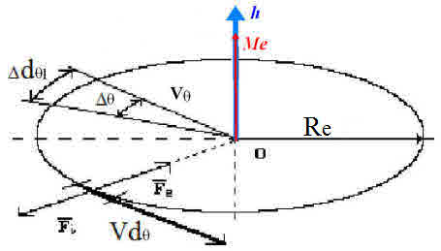





Fig-39: Ring model of an electron

The following works on each element of the ring:

* , (equation 160 in differential form)
* Charge repulsion,
* magnetic attraction

The constant velocity around the axis is:



Therefore,  (161)

A dimensions check on the left and right of equation yields (160).



Since they are identical, equation (160) & (161) are reliable.

Designating the distribution of mass on the ring as, and the charge as, we have:

 (162)

 (163)

Rearranging, we have:  (164)

 (165)

Since, equation (160) becomes: 

Integrating,  (166)

Equation (166) is a ratio that includes:

* mass  of free electron,
* its charge ,
* intensity of the magnetic flux densityinside the ring which is generated by the charge moving around the ring,
* angular velocity 
* Radius of an electron.

Equation (166) does not include Bohr’s magneton ratio.

 (167)

In equation (167),  gives an arrow property to. Transforming equation (166):



From this we have 

Equation (168) allows the calculation of:

* : The intensity of a magnetic flux inside the ring model of an electron,
* : The angular velocity of the ring
* : The radius of the electron

 (170)

is a very large magnetic intensity in the center of the electron's symmetry.

Putting this number in equation (166), we have: (171)

This is the same value calculated using equations (154) and (158).

Rearranging equation (169) to obtain the radius of an electron:

  (172)

Solving for:

 (173)

where

* 
* : Intensity of magnetic flux density at the center of symmetry of an electron.

The main parameter of the ring model of a free electron is its radius. The calculated value of the radiususing equations (146), (160) and (173) give the same values. The experimental wavelength using Compton's equation (148) gives the same value.

A ring electron forms a charge intensity.

 (174)

This is an enormous intensity. 

Because the ring model equations do not explain the formation of a positron, the ring should have any internal structure. A torus allows a ring to have an internal structure.

The most important feature of the electron ring theory is that the vectors  and  point in the same direction. The symbol is named the magnetic arrow of a single electron.

**8.4. Torus model of the electron**

Expanding on the ring model, we move to a torus model. The radius of the torus circle will be designate as. The surface area of an electron torus is:

 (175)

Calculating the mass to surface area ratio of the electron, we have: 

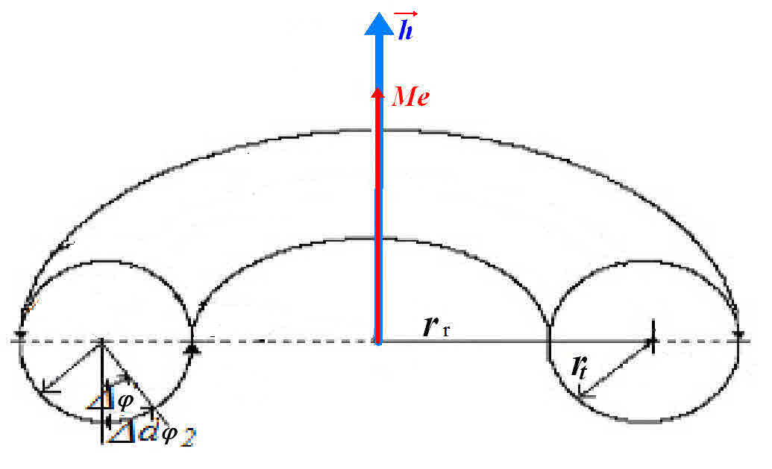

Fig-40: Torus model of an electron

The mass distributionof a torus is:

 (177)

 (178)

 (179)

Because electrons show charge, magnetics and angular momentum simultaneously, we theorize that it has two rotations.

* The first rotation is around its axis of symmetry with an angular velocity.
  + We will label this rotation, its angular momentum  and its.
* The second rotation is around the torus ring axis with angular velocity. We label this as potential rotation and its magnetic moment.
  + The rotation of the torus ring axis forms the magnetic action of an electron.

The full photon will consist of the motion and potential .

The motionof a rotating torus will be:

 (180)

Taking into account that the frequency  (171), we have

 (181)

Equation (181) shows that the motion of an electron is equal to half of its full photon (167). This confirms our postulate.

The radius of the small torus section  defines the potential rotation of the electron with frequency. We state that:

 (182)

Since the speed of light in a vacuum is a constant, the speed of points on the torus axis of rotation is equal to speed of points on the surface of the torus.

 (183)

From these equations, we get

 (184)

And

 (185)

Since this rotation generates its potential, we have

 (186)

The potential of an electron is equal to its motion. Combining equations (181 and 186), we calculate the full photon of a free electron.



Equations (182) and (183) are proved by showing that the motion and potential give the same answer as the experimental value.

We shall derive equations to show that the intensity of the charge is on the surface of the torus. Taking into account the area of its surface: and a ratio between radiuses, we have

 (187)

This is a large charge intensity. The charge intensity decreases proportionally to the square of the distance from the surface of the torus. The mass per area of the torus is:

 (188)

From our postulate that an electron is a torus, Bohr’s magneton  should follow.

The radius of a torus section is. The dependences between a current  in a section of a wire with a radius of  is . The dependence of the magnetic moment  formed around a conductor wire by a current is . Using this to calculate Bohr’s magneton: 

Checking units, we have:

 (190)

The units are correct and equation (189) is reliable.

The agreement of different equation concepts for the calculation of theof an electron, the Bohr’s magneton and the radius of an electron means that representing an electron as a closed torus that rotates around it axis of symmetry and the torus' axis of symmetry is valid. These two rotations generate the motion, potential, and the magnetic moment of the electron.

The handbook of Chemistry and Physics shows the "classical radius of the electron" as . Kanarev's theory shows this to be the radius of approach of the magnetic force lines around the torus ring of the electron.

This is confirmed by calculating the dimensionless fine structure constant (which is equal to the circumference the inner circle  divided by the radius of the electron.

 (191)

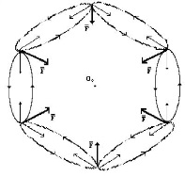 What happens when an external decelerates the rotation of the torus? Six vertical radial rings are immediately formed. They form a six-ring magnetic action closed on each other. The slightest change to this structure starts the structure to rotating. The asymmetry between its structures causes it to return to a straight line motion at the speed of light.

Again, theof an electron is equal to Planck's constant time the angular velocity. When an electron emits a photon, its will decrease due to the change in its mass. For Planck's constant to remain a constant, when the radius of an electron  increases, the angular velocitydecreases.

When an electron losses mass, it is unstable and seeks to restore it mass. If a photon is close to the electron, it will absorb it and restore all constants. If there is no photon available, the electron will absorb a photon from the photon sea of space. It will absorb photons from the photon sea of space until the constants are restored.

All free electrons have the same constant mass, charge and radiuses. When an electron establishes a connection with another valence electron, it emits a photon. The parameters change, but stability is kept due to the bonding with a proton or with another valence electron. If this bond is broken by mechanical means, the stable condition of the electron disappears. To restore stability, electrons absorb photons from the photon sea. After absorption, the electron becomes stable again.

The radiuses of visible light (3E-4 to 7E-7*m*) and infra-red (7.7E-7 to 3.8E-7*m*) photons are approximately five orders of magnitude larger  than the radius of an electron (2.4E-12*m*). At the moment of photon emission, the ring’s magnetic action forms the final photon radius a significant distance from the electron. This final photon radius is determined by transient time to go from velocity  up to the speed of light. This distance decreases as theof the photon or it radius increases. Electrons emit photons up to the radius of x-ray photon. An electron cannot radiate a gamma ray photon. Gamma rays are emitted when protons bond to form nuclei.

An Electron model that agrees with experiments is a duel rotating torus. Its structure remains steady due to the presence of the two rotations.

* The first rotation is around the axis of the geometrical center of the torus and is perpendicular to the rotation plane
* The second rotation is a vortical rotation around the torus axis.

Different methods of calculating the radius of a torus give the same result as Compton's experimental value.

Kanarev’s model of an electron contain the following constants:

* : 
* C: speed of light
* : Planck's constant,
* : electron's rest mass
* : charge on electron
* : charge constant
* : Bohr’s magneton which we designate 
* : Compton’s wavelength: named the Compton’s radius  of an electron.

Another important characteristic of the electron is its spin. An electron's spin is equal to Planck’s constant and has an arrow magnitude of. The arrow properties follow from its angular momentum.

A third important characteristic of the electron is its magnetic arrowwhich generates the intensity of a magnetic flux density  around the electron. The magnitude of this flux density at the geometrical center is equal to.  is a very large magnitude. However, the magnitude of this magnetic flux decreases rapidly as a function of its distance from the geometrical center of the axis of rotation of the electron.

In summary, an electron is a torus which has two rotations:

* Rotation one is around the axis of the ring.
  + This rotation is the angular momentum arrow 
* Rotation two is around the axis of the torus.
  + This rotation forms the magnetic flux of the electron.
  + The magnetic flux lines form a bar magnet actions.

The torus model of an electron allows the formation of clusters by electrons. The electron's magnetic arrows attract while the charges repulse. This attraction and repulsion allows electron's to form clusters. There are experiments that prove this takes place.

Electrons contain more than 20 constants in which the numerous equations predict its behavior.

**8.5. The Proton**

The rest mass of a proton is.

The Compton wavelength of a proton is.

The constant of a proton is the same as the photon and electron.

 (192)

A first approximation for a model of a proton will be a ring.

 (193)

*  - the magnetic moment of a proton;
* - Intensity of the magnetic flux in its geometrical center.

 (194)

The radius of the proton calculated using equation (193) agrees with Compton wavelength



Calculating the classical radius  of a proton, we have:

 (195)

This radiusis three orders of magnitude less than the radius. is the limit of approach of its magnetic flux lines.

The radius of a protonis three orders of magnitude less than the radius of an electron.

The spin of a proton is equal to Planck's constant and is directed along its axis of rotation. The charge on a proton is opposite to the charge on an electron. This means that the spin of the proton  must be in the opposite direction to the spin of an electron. The magnetic moment of the proton  must also be in the opposite direction of the magnetic moment of the electron.

Therefore, it is necessary to write the formula with plus for electron and with a minus for a proton. (JK: Symmetry Math removes positive and negatives. Electrons are not negative and protons are not positive. They simply have rotation in different directions. The labels of positive and negative have confused and clouded theories since their first use.)

 (196)



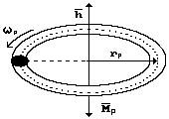

Fig-42: Proton

The intensity of the magnetic flux near the geometrical center of the proton ring is so great that we theorize that it is the ***strong nuclear force***.

The intensity of the magnetic flux near the geometrical center of a proton can be calculated using its energy 

 (197)

The magnetic flux of protons attracts and the charges repulse. Since Protons bond in hydrogen molecules, the magnetic flux is stronger than the charge repulsion. This is the phenomenon that bonds hydrogen atoms to form hydrogen molecules and that allows hydrogen atoms to bond to various other atoms to form molecules.

The intensity of the attractive/repulsive charge of a proton  is 6 orders of magnitude larger than the attractive/repulsive charge of an electron.

 (198)

Kanarev theorize that a proton is a torus ring that is filled with a substance such that the torus' volumetric density  should be close to the density of the nucleus 

 (199)

If we view a proton as a sphere with a radius of, when they make contact, the repulsive between them will be:

 (200)

For comparison, here are calculations for the gravitational attraction between two protons.

 (201)

These calculations show that it is the charge and magnetic actions that are used to form nuclei. The gravitational attraction is too weak to be involved.

A proton is a thin torus. The charge and magnetic flux lines of a proton resemble that of an apple. The charge flux lines are perpendicularly to the magnetic flux lines and the ring surface. The proton has almost a spherical charge action.

The proton has two magnetic arrows: and 

The direction of the angular momentum arrowis in the opposite direction of the magnetic flux arrow. The angular momentum arrowof the proton points in the opposite direction to the angular momentum arrow of the electron. Because the density of the proton torus is close to the density of a nucleus, the torus should have only one axis of rotation. We model the proton as a thin torus.

**8.6 The Neutron**

The rest mass of a neutron is.

The magnetic moment of the neutron is.

The Compton wavelength a neutron is.

The constant of a neutron is equal to the constant of a photon, electron and a proton.

 (202)

The external net charge on a neutron is zero. As the mass of a neutron is only slightly more than the mass of a proton, the radius of a neutron and proton are very close.

We postulate that a neutron has six mutually perpendicular magnetic arrows. The magnetic actions of a neutron reveal the structure of nuclei.

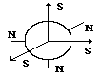

Fig-43: Neutron

The theoretical neutron radius is:

 (203)

The constants of the basic elementary particles: a photon, electron, proton and neutron and all other known particles are equal.

 (204)

The difference in mass of a neutron and a proton is equal to:



If you divide the mass difference  by the mass of an electron, you obtain the number of electrons needed to make a proton into a neutron iselectrons.

If a proton becomes a neutron, it should absorb 2.531 electrons. Since electrons do not exist in fractions, a proton must absorb an integer number of electrons. If a proton absorbs three electrons, where does the additional massgo? Modern physics predicted the birth of a neutrino (a particle with no charge that is very difficult to detect). Kanarev believes a better hypothesis is that the extra mass is absorbed by the photon sea of space.

The classical radius of the neutron is:

 (205)

We do not see a reason to attribute this radius to the geometrical size of a neutron.

is the radius of approach of the central magnetic flux lines.

**Summary:** The convergence of theoretical and experimental results is so significant that Kanarev’s equations should be used to describe the behavior of electrons, protons and neutrons.

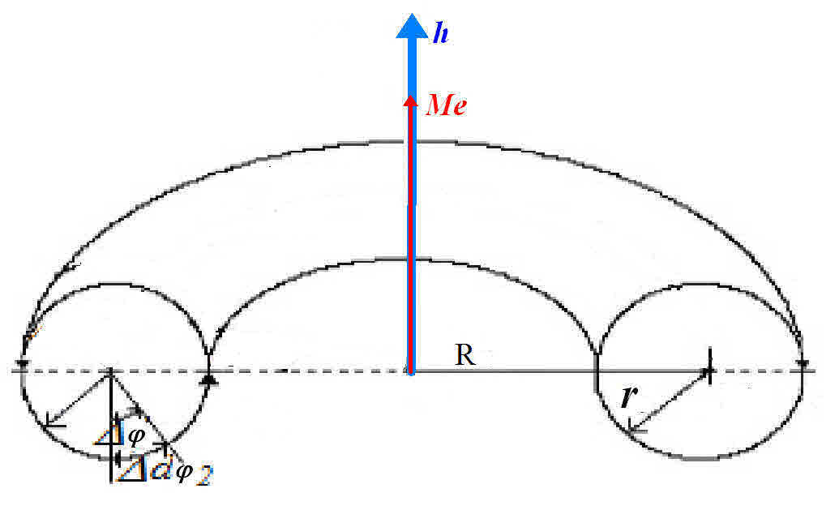

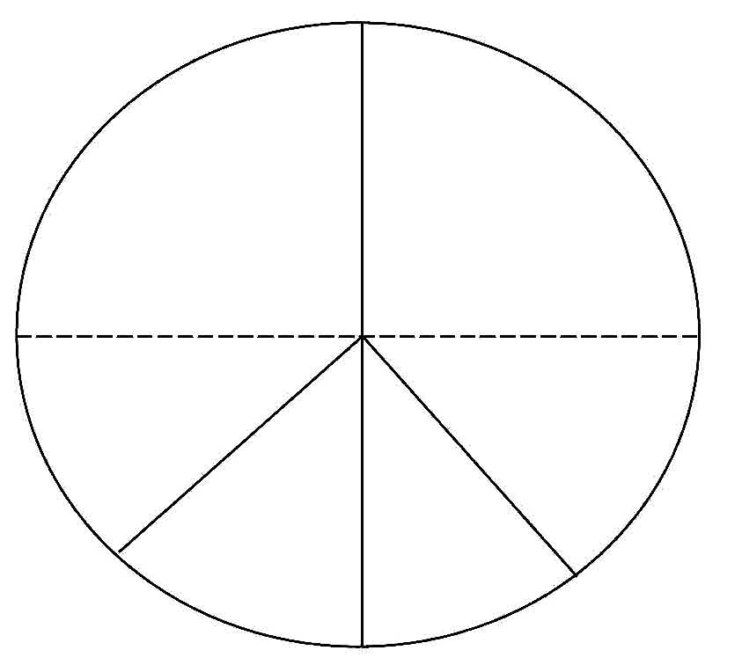



ARc and ARmag for Electrons, Protons and Neutrons

Attractive/Repulsive-charge (ARc)

One is that point charge which at a distance of one meter in a vacuum from an equal, like point charge repels it with anof approximately.

In the mks system equals: 

More precisely  where 

*  is called the permittivity of a vacuum.
*  is an experimentally determined constant. It is not arbitrary
* Permittivity: The ratio of the flux density produced by a charge flux in a given dielectric to the flux density produced by that flux in a vacuum.

The factor () is introduced arbitrarily for reasons of convenience. Inserting it into Coulomb’s law permits cancellation of a factor of () that we shall encounter later on.



Example: Using BS Math, whatdoes a positive point charge of exert on a negative point charge ofat a distance of 0.10m in a vacuum?

BS Math - uses positive and negative to represent charge.



The negative (dash) sign means theis attractive. A positive (+ sign) is repulsive. The understanding of a simple principle becomes extremely confusing by using the words negative and positive. There is NOTHING negative or positive about either charge. Letting the dash symbol (-) mean attractive and the cross symbol (+) mean repulsion, is a **MAJOR ERROR** in understanding math and physics principles.

Using Symmetry Math, the answer is easily understood.



* 
* Opposite direction arrows attract. Same direction arrows repulse

The principle is now simple and easily understood.

Electron:  – Mass – Frequency – Radius - Charge

: 

 : 

Mass: 

Frequency: 

Radius: 

Charge: 



NOTE: The electron volt is not aunit.



The current definition of an eV is incorrect! JK: did not change to units.

A volt is a measure of electric potential. An electron volt (abbreviated eV) is a measure of energy, defined as the amount of energy contained in a charge of 1 electron at a potential of one volt. The charge on an electron is about 1.6 E-19 coulombs (or 6 E18 electrons per coulomb). An electric current flow of 1 coulomb per second is 1 ampere.  
  
For example, if you have a 9 volt battery putting out a current of 0.1 amps then each electron has an available energy 9 eV. The electron energy in eV is the same as the battery voltage in volts. The 0.1 amps is how many electrons per second are flowing, for 0.1 amps that is 6E17 electrons per second.  
  
In SI units, 1 eV is 1.6E-19 Joule and one Volt is 1 Joule/Coulomb

JK: 



|  |  |  |  |  |  |  |  |  |  |  |  |  |  |
| --- | --- | --- | --- | --- | --- | --- | --- | --- | --- | --- | --- | --- | --- |
| Particle |  | |  |  |  |  |  | | --- | --- | --- | --- | --- | | K = 1E3 | g = grams | m = meters | s = seconds | | | A Amperes = | J = Joule | T = Tesla = | | 1E3 = 1000 | | |
|  |  | Magnetic Moment |
|  | M*e* |  |
|  | M*p* |  |
|  | M*n* |  |
|  |  |  |
|  |  |  |
|  |  |  |
| *Be* |  |  |
| *Bp* |  |  |
|  |  |  |
| *Me* |  |  |



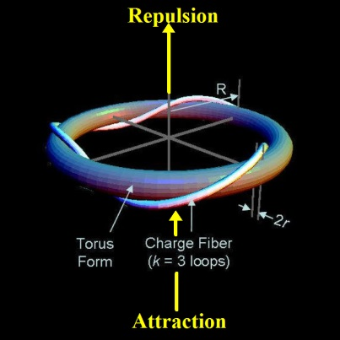

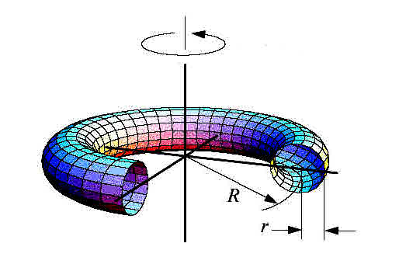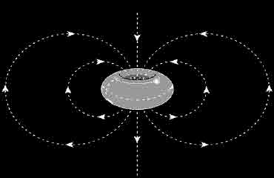

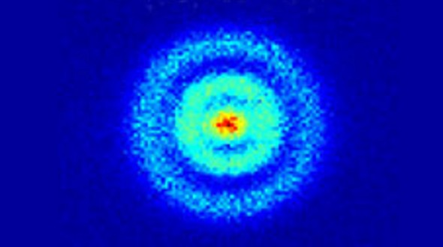

<http://www.geek.com/wp-content/uploads/2013/05/orbital-590x330.jpg>

Appendix-1

The Circle - Symmetry Math (SM)

|  |  |
| --- | --- |
| The SM circle is based on 6.283185307 degrees  1h - 6 | *r*  ** |
| SM vs BS - 1 | |  |  |  |  |  | | --- | --- | --- | --- | --- | |  | SM | sin | cos | tan | |  | 0.000000 | 0.0000 | 1.0000 | 0.0000 | |  | 0.010000 | 0.0100 | 1.0000 | 0.0100 | |  | 0.100000 | 0.0998 | 0.9950 | 0.1003 | |  | 0.200000 | 0.1986 | 0.9800 | 0.2027 | |  | 0.300000 | 0.2955 | 0.9553 | 0.3093 | |  | 0.400000 | 0.3894 | 0.9211 | 0.4228 | |  | 0.500000 | 0.4794 | 0.8776 | 0.5463 | |  | 0.600000 | 0.5646 | 0.8253 | 0.6841 | |  | 0.700000 | 0.6442 | 0.7648 | 0.8423 | |  | 0.800000 | 0.7174 | 0.6967 | 1.0296 | |  | 0.900000 | 0.7833 | 0.6216 | 1.2602 | |  | 1.000000 | 0.8415 | 0.5403 | 1.5574 | |  | 1.100000 | 0.8912 | 0.4536 | 1.9648 | |  | 1.200000 | 0.9320 | 0.3624 | 2.5722 | |  | 1.300000 | 0.9636 | 0.2675 | 3.6021 | |  | 1.400000 | 0.9854 | 0.1700 | 5.7979 | |  | 1.500000 | 0.9975 | 0.0707 | 14.1014 | |  | 1.570796 | 1.0000 | 0.0000 | 1/0 is undefined | |
| In SM, the sin of 1.57o is equal to 1. | |  |  | | --- | --- | | 3.141592654 | ❐ | | 6.283185307 |  | | 0.01745329252 | 1/57.29577951 | | x = *r* cos | cos =x/r | | y = r sin | sin = y/r | | y = x tan | tan = y/x | |  |  | |

Rotational Motion – Symmetry Math (SM)

One radian is an angle whose arc distance is equal to its radius.



Circumference of a circle is equal to times its radius.



In SM, the sin of 1.57 degrees is equal to 1. In BS math, the sin of 90 degrees is equal to 1.



|  |  |  |
| --- | --- | --- |
| radians and degrees are the same in SM math | *r*  ** |  |

* * = angle in radians (0 to 6.28 radians) (1o = 1 radian) * * = angle in degrees

|  |  |  |  |  |  |  |
| --- | --- | --- | --- | --- | --- | --- |
|  | | | The average angular velocity of a body is the rate of its angular displacement. | | | |
|  | | | The instantaneous angular velocity is the limit of the ratio as approaches zero | | | |
|  | | | The average velocity of any point on the body is the rate of the distance traveled divided by the time | | | |
|  |  | | | | | The equation of the relationship between the angular velocity and the velocity of a point on that body |
|  | | | | The average angular acceleration is the change in the angular velocity. | | |
|  | | | | The instantaneous angular acceleration is the limit of the ration of as approaches zero | | |
|  | |  | | | The equation of the relationship between the angular acceleration and the acceleration of a point on the body | |
|  | | If a body with an initial angular velocity has a constant angular acceleration, it will turn through an angle in a time ***t*** | | | | |





*The 360-degree circle is 4400 years old and outdated.

Q: Why does a circle have 360 degrees; why not 100 degrees? Also why is a degree 60 minutes and a minute 60 seconds? **--HSR, Pakistan**

**A:** Ancient peoples (Sumerians, Akkadians, and Babylonians) who lived in Mesopotamia invented writing, observed the skies, and invented a 360-degree circle to describe their findings. About 3000 BC, the Sumerians invented writing. They also had a calendar, dating from 2400 BC, that divided the year into 12 months of 30 days each, that is, 360 days.

The Sumerians watched the Sun, Moon, and the five visible planets (Mercury, Venus, Mars, Jupiter, and Saturn), primarily for omens. They did not try to understand the motions physically. They did, however, notice the circular track of the Sun's annual path across the sky and knew that it took about 360 days to complete one year's circuit. Consequently, they divided the circular path into 360 degrees to track each day's passage of the Sun's whole journey. This probably happened about 2400 BC.

A 100-degree circle makes sense for base 10 people like us. But the base-60 Babylonians came up with 360o and we cling to their ways-4,400 years later.

Symmetry Math (SM) is changing the older system to an easier to use and understand system that will have a circle of 6.283185307o.

|  |  |  |  |  |
| --- | --- | --- | --- | --- |
| BS | SM | sin | cos | tan |
| 0.000000 | 0.000000 | 0.0000 | 1.0000 | 0.0000 |
| 0.5729577951 | 0.010000 | 0.0100 | 1.0000 | 0.0100 |
| 1.14592 | 0.020000 | 0.0200 | 0.9998 | 0.0200 |
| 1.71887 | 0.030000 | 0.0300 | 0.9996 | 0.0300 |
| 2.29183 | 0.040000 | 0.0400 | 0.9992 | 0.0400 |
| 2.86479 | 0.050000 | 0.0500 | 0.9988 | 0.0500 |
| 3.43775 | 0.060000 | 0.0600 | 0.9982 | 0.0601 |
| 4.01070 | 0.070000 | 0.0699 | 0.9976 | 0.0701 |
| 4.58366 | 0.080000 | 0.0799 | 0.9968 | 0.0802 |
| 5.15662 | 0.090000 | 0.0899 | 0.9960 | 0.0902 |
| 5.72958 | 0.100000 | 0.0998 | 0.9950 | 0.1003 |
| 6.30254 | 0.110000 | 0.1098 | 0.9940 | 0.1104 |
| 6.87549 | 0.120000 | 0.1197 | 0.9928 | 0.1206 |
| 7.44845 | 0.130000 | 0.1296 | 0.9916 | 0.1307 |
| 8.02141 | 0.140000 | 0.1395 | 0.9902 | 0.1409 |
| 8.59437 | 0.150000 | 0.1494 | 0.9888 | 0.1511 |
| 9.16732 | 0.160000 | 0.1593 | 0.9872 | 0.1614 |
| 9.74028 | 0.170000 | 0.1692 | 0.9856 | 0.1717 |
| 10.31324 | 0.180000 | 0.1790 | 0.9838 | 0.1820 |
| 10.88620 | 0.190000 | 0.1889 | 0.9820 | 0.1923 |
| 11.45916 | 0.200000 | 0.1987 | 0.9801 | 0.2027 |
| 12.03211 | 0.210000 | 0.2085 | 0.9780 | 0.2131 |
| 12.60507 | 0.220000 | 0.2182 | 0.9759 | 0.2236 |
| 13.17803 | 0.230000 | 0.2280 | 0.9737 | 0.2341 |
| 13.75099 | 0.240000 | 0.2377 | 0.9713 | 0.2447 |
| 14.32394 | 0.250000 | 0.2474 | 0.9689 | 0.2553 |
| 14.89690 | 0.260000 | 0.2571 | 0.9664 | 0.2660 |
| 15.46986 | 0.270000 | 0.2667 | 0.9638 | 0.2768 |
| 16.04282 | 0.280000 | 0.2764 | 0.9611 | 0.2876 |
| 16.61578 | 0.290000 | 0.2860 | 0.9582 | 0.2984 |
| 17.18873 | 0.300000 | 0.2955 | 0.9553 | 0.3093 |
| 17.76169 | 0.310000 | 0.3051 | 0.9523 | 0.3203 |
| 18.33465 | 0.320000 | 0.3146 | 0.9492 | 0.3314 |
| 18.90761 | 0.330000 | 0.3240 | 0.9460 | 0.3425 |
| 19.48057 | 0.340000 | 0.3335 | 0.9428 | 0.3537 |
| 20.05352 | 0.350000 | 0.3429 | 0.9394 | 0.3650 |
| 20.62648 | 0.360000 | 0.3523 | 0.9359 | 0.3764 |
| 21.19944 | 0.370000 | 0.3616 | 0.9323 | 0.3879 |
| 21.77240 | 0.380000 | 0.3709 | 0.9287 | 0.3994 |
| 22.34535 | 0.390000 | 0.3802 | 0.9249 | 0.4111 |
| 22.91831 | 0.400000 | 0.3894 | 0.9211 | 0.4228 |
| 23.49127 | 0.410000 | 0.3986 | 0.9171 | 0.4346 |
| 24.06423 | 0.420000 | 0.4078 | 0.9131 | 0.4466 |
| 24.63719 | 0.430000 | 0.4169 | 0.9090 | 0.4586 |
| 25.21014 | 0.440000 | 0.4259 | 0.9048 | 0.4708 |
| 25.78310 | 0.450000 | 0.4350 | 0.9004 | 0.4831 |
| 26.35606 | 0.460000 | 0.4439 | 0.8961 | 0.4954 |
| 26.92902 | 0.470000 | 0.4529 | 0.8916 | 0.5080 |
| BS | SM | SIN | COS | TAN |
| 27.50197 | 0.480000 | 0.4618 | 0.8870 | 0.5206 |
| 28.07493 | 0.490000 | 0.4706 | 0.8823 | 0.5334 |
| 28.64789 | 0.500000 | 0.4794 | 0.8776 | 0.5463 |
| 29.22085 | 0.510000 | 0.4882 | 0.8727 | 0.5594 |
| 29.79381 | 0.520000 | 0.4969 | 0.8678 | 0.5726 |
| 30.00000 | 0.523599 | 0.5000 | 0.8660 | 0.5774 |
| 30.36676 | 0.530000 | 0.5055 | 0.8628 | 0.5859 |
| 30.93972 | 0.540000 | 0.5141 | 0.8577 | 0.5994 |
| 31.51268 | 0.550000 | 0.5227 | 0.8525 | 0.6131 |
| 32.08564 | 0.560000 | 0.5312 | 0.8473 | 0.6269 |
| 32.65859 | 0.570000 | 0.5396 | 0.8419 | 0.6410 |
| 33.23155 | 0.580000 | 0.5480 | 0.8365 | 0.6552 |
| 33.80451 | 0.590000 | 0.5564 | 0.8309 | 0.6696 |
| 34.37747 | 0.600000 | 0.5646 | 0.8253 | 0.6841 |
| 34.95043 | 0.610000 | 0.5729 | 0.8196 | 0.6989 |
| 36.09634 | 0.630000 | 0.5891 | 0.8080 | 0.7291 |
| 36.66930 | 0.640000 | 0.5972 | 0.8021 | 0.7445 |
| 37.24226 | 0.650000 | 0.6052 | 0.7961 | 0.7602 |
| 37.81521 | 0.660000 | 0.6131 | 0.7900 | 0.7761 |
| 38.38817 | 0.670000 | 0.6210 | 0.7838 | 0.7923 |
| 38.96113 | 0.680000 | 0.6288 | 0.7776 | 0.8087 |
| 39.53409 | 0.690000 | 0.6365 | 0.7712 | 0.8253 |
| 40.10705 | 0.700000 | 0.6442 | 0.7648 | 0.8423 |
| 40.68000 | 0.710000 | 0.6518 | 0.7584 | 0.8595 |
| 41.25296 | 0.720000 | 0.6594 | 0.7518 | 0.8771 |
| 41.82592 | 0.730000 | 0.6669 | 0.7452 | 0.8949 |
| 42.39888 | 0.740000 | 0.6743 | 0.7385 | 0.9131 |
| 42.97183 | 0.750000 | 0.6816 | 0.7317 | 0.9316 |
| 43.54479 | 0.760000 | 0.6889 | 0.7248 | 0.9505 |
| 44.11775 | 0.770000 | 0.6961 | 0.7179 | 0.9697 |
| 44.69071 | 0.780000 | 0.7033 | 0.7109 | 0.9893 |
| 45.00000 | 0.785398 | 0.7071 | 0.7071 | 1.0000 |
| 45.26367 | 0.790000 | 0.7104 | 0.7038 | 1.0092 |
| 45.83662 | 0.800000 | 0.7174 | 0.6967 | 1.0296 |
| 46.40958 | 0.810000 | 0.7243 | 0.6895 | 1.0505 |
| 46.98254 | 0.820000 | 0.7311 | 0.6822 | 1.0717 |
| 47.55550 | 0.830000 | 0.7379 | 0.6749 | 1.0934 |
| 48.12845 | 0.840000 | 0.7446 | 0.6675 | 1.1156 |
| 48.70141 | 0.850000 | 0.7513 | 0.6600 | 1.1383 |
| 49.27437 | 0.860000 | 0.7578 | 0.6524 | 1.1616 |
| 49.84733 | 0.870000 | 0.7643 | 0.6448 | 1.1853 |
| 50.42029 | 0.880000 | 0.7707 | 0.6372 | 1.2097 |
| 50.99324 | 0.890000 | 0.7771 | 0.6294 | 1.2346 |
| 51.56620 | 0.900000 | 0.7833 | 0.6216 | 1.2602 |
| 52.13916 | 0.910000 | 0.7895 | 0.6137 | 1.2864 |
| 52.71212 | 0.920000 | 0.7956 | 0.6058 | 1.3133 |
| 53.28507 | 0.930000 | 0.8016 | 0.5978 | 1.3409 |
| 53.85803 | 0.940000 | 0.8076 | 0.5898 | 1.3692 |
| BS | SM | SIN | COS | TAN |
| 54.43099 | 0.950000 | 0.8134 | 0.5817 | 1.3984 |
| 55.00395 | 0.960000 | 0.8192 | 0.5735 | 1.4284 |
| 55.57691 | 0.970000 | 0.8249 | 0.5653 | 1.4592 |
| 56.14986 | 0.980000 | 0.8305 | 0.5570 | 1.4910 |
| 56.72282 | 0.990000 | 0.8360 | 0.5487 | 1.5237 |
| 57.29578 | 1.000000 | 0.8415 | 0.5403 | 1.5574 |
| 57.86874 | 1.010000 | 0.8468 | 0.5319 | 1.5922 |
| 58.44170 | 1.020000 | 0.8521 | 0.5234 | 1.6281 |
| 59.01465 | 1.030000 | 0.8573 | 0.5148 | 1.6652 |
| 59.58761 | 1.040000 | 0.8624 | 0.5062 | 1.7036 |
| 60.00000 | 1.047198 | 0.8660 | 0.5000 | 1.7321 |
| 60.16057 | 1.050000 | 0.8674 | 0.4976 | 1.7433 |
| 60.73353 | 1.060000 | 0.8724 | 0.4889 | 1.7844 |
| 61.30648 | 1.070000 | 0.8772 | 0.4801 | 1.8270 |
| 61.87944 | 1.080000 | 0.8820 | 0.4713 | 1.8712 |
| 62.45240 | 1.090000 | 0.8866 | 0.4625 | 1.9171 |
| 63.02536 | 1.100000 | 0.8912 | 0.4536 | 1.9648 |
| 63.59832 | 1.110000 | 0.8957 | 0.4447 | 2.0143 |
| 64.17127 | 1.120000 | 0.9001 | 0.4357 | 2.0660 |
| 64.74423 | 1.130000 | 0.9044 | 0.4267 | 2.1198 |
| 65.31719 | 1.140000 | 0.9086 | 0.4176 | 2.1759 |
| 65.89015 | 1.150000 | 0.9128 | 0.4085 | 2.2345 |
| 66.46310 | 1.160000 | 0.9168 | 0.3993 | 2.2958 |
| 67.03606 | 1.170000 | 0.9208 | 0.3902 | 2.3600 |
| 67.60902 | 1.180000 | 0.9246 | 0.3809 | 2.4273 |
| 68.18198 | 1.190000 | 0.9284 | 0.3717 | 2.4979 |
| 68.75494 | 1.200000 | 0.9320 | 0.3624 | 2.5722 |
| 69.32789 | 1.210000 | 0.9356 | 0.3530 | 2.6503 |
| 69.90085 | 1.220000 | 0.9391 | 0.3436 | 2.7328 |
| 70.47381 | 1.230000 | 0.9425 | 0.3342 | 2.8198 |
| 71.04677 | 1.240000 | 0.9458 | 0.3248 | 2.9119 |
| 71.61972 | 1.250000 | 0.9490 | 0.3153 | 3.0096 |
| 72.19268 | 1.260000 | 0.9521 | 0.3058 | 3.1133 |
| 72.76564 | 1.270000 | 0.9551 | 0.2963 | 3.2236 |
| 73.33860 | 1.280000 | 0.9580 | 0.2867 | 3.3413 |
| 73.91156 | 1.290000 | 0.9608 | 0.2771 | 3.4672 |
| 74.48451 | 1.300000 | 0.9636 | 0.2675 | 3.6021 |
| 75.05747 | 1.310000 | 0.9662 | 0.2579 | 3.7471 |
| 75.63043 | 1.320000 | 0.9687 | 0.2482 | 3.9033 |
| 76.77634 | 1.340000 | 0.9735 | 0.2288 | 4.2556 |
| 77.34930 | 1.350000 | 0.9757 | 0.2190 | 4.4552 |
| 77.92226 | 1.360000 | 0.9779 | 0.2092 | 4.6734 |
| 78.49522 | 1.370000 | 0.9799 | 0.1994 | 4.9131 |
| 79.06818 | 1.380000 | 0.9819 | 0.1896 | 5.1774 |
| 79.64113 | 1.390000 | 0.9837 | 0.1798 | 5.4707 |
| 80.21409 | 1.400000 | 0.9854 | 0.1700 | 5.7979 |
| 80.78705 | 1.410000 | 0.9871 | 0.1601 | 6.1654 |
| 81.36001 | 1.420000 | 0.9887 | 0.1502 | 6.5811 |
| BS | SM | SIN | COS | TAN |
| 81.93296 | 1.430000 | 0.9901 | 0.1403 | 7.0555 |
| 82.50592 | 1.440000 | 0.9915 | 0.1304 | 7.6018 |
| 83.07888 | 1.450000 | 0.9927 | 0.1205 | 8.2381 |
| 83.65184 | 1.460000 | 0.9939 | 0.1106 | 8.9886 |
| 84.22480 | 1.470000 | 0.9949 | 0.1006 | 9.8874 |
| 84.79775 | 1.480000 | 0.9959 | 0.0907 | 10.9834 |
| 85.37071 | 1.490000 | 0.9967 | 0.0807 | 12.3499 |
| 85.94367 | 1.500000 | 0.9975 | 0.0707 | 14.1014 |
| 86.51663 | 1.510000 | 0.9982 | 0.0608 | 16.4281 |
| 87.08958 | 1.520000 | 0.9987 | 0.0508 | 19.6695 |
| 87.66254 | 1.530000 | 0.9992 | 0.0408 | 24.4984 |
| 88.23550 | 1.540000 | 0.9995 | 0.0308 | 32.4611 |
| 88.80846 | 1.550000 | 0.9998 | 0.0208 | 48.0785 |
| 89.38142 | 1.560000 | 0.9999 | 0.0108 | 92.6205 |
| 89.95437 | 1.570000 | 1.0000 | 0.0008 | 1255.7658 |
| 90.00000 | 1.570796 | 1.0000 | 0.0000 | 1/0 is undefined |
|  |  |  |  |  |
|  |  |  |  |  |
|  |  |  |  |  |