Coil: Torqueing the Upper Body against the Lower Body

It is easy to be misled by an accepted authority figure. Jim McLean and Golf Digest have been promoting his dangerous and scientifically incorrect X-Factory since 1992.
I will go through some anatomy before analyzing COIL.
- There is a right and left shoulder.
  - They rotate independently of each other.
- The hips are one unit and rotates at one unit.
- The maximum you can rotate the right shoulder behind the right hip is 30%.
  - There are 15 vertebras that rotate approximately 2 degrees each.

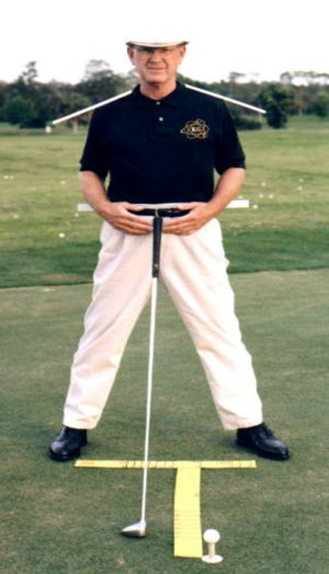 | I have placed white plastic strips:  - on each shoulder  - and behind my hips  I have pulled my shoulders backward to be in line with my hips. You will notice that my fingers do not touch. You cannot grip a golf club if your shoulders are pulled backward

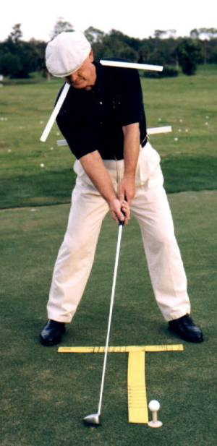 | 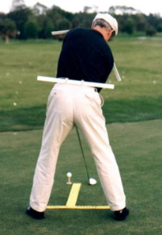

When the grip is taken, the right shoulder rotates forward around 90 degrees because the right hand is below the left. The left shoulder will rotate forward around 30 degrees. The angles between the shoulders and hips are obvious from the photos.

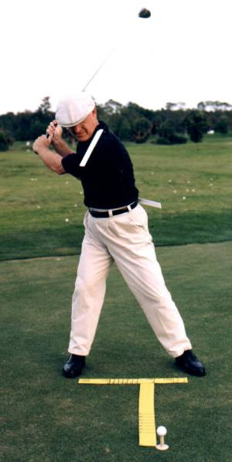 | 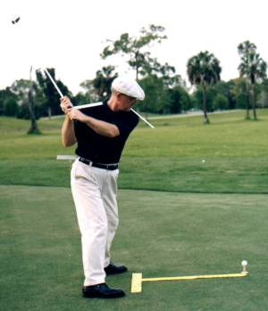
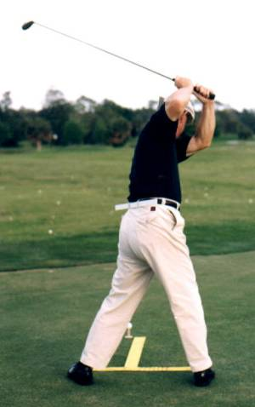 | 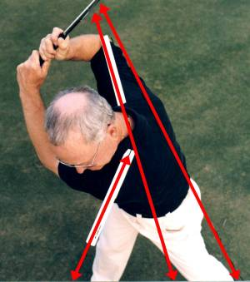

At the top of the backstroke:
- The right shoulder will rotate, independent of the left shoulder, rearward from the initial 90 degrees forward of the right hip, to around 10 to 20 degrees rearward of the right hip. There is virtually NO torqueing of the right shoulder to the right hip.
- The left shoulder will rotate, independent of the right shoulder, an additional 60 to 90 degrees forward of the left hip. You will feel some tension in the left shoulder area due to the rotation.

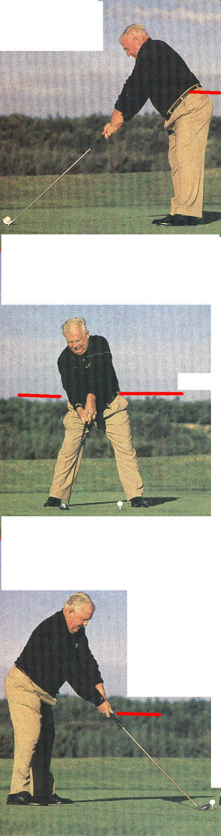
Now, let’s analyze the hip and shoulder action of Moe Norman (Considered by many to be the greatest ball striker to ever play the game).
Moe sets up with his hips almost parallel to the ground. Red line in 1st photo shows his left hip position.

Both of Moe’s hips are just above the tree line.

Moe’s right shoulder is 9 inches below his left shoulder (personally measured by me). Both shoulders are rotated forward of the hips.

The red line is in line with the bottom of Moe’s right hand.

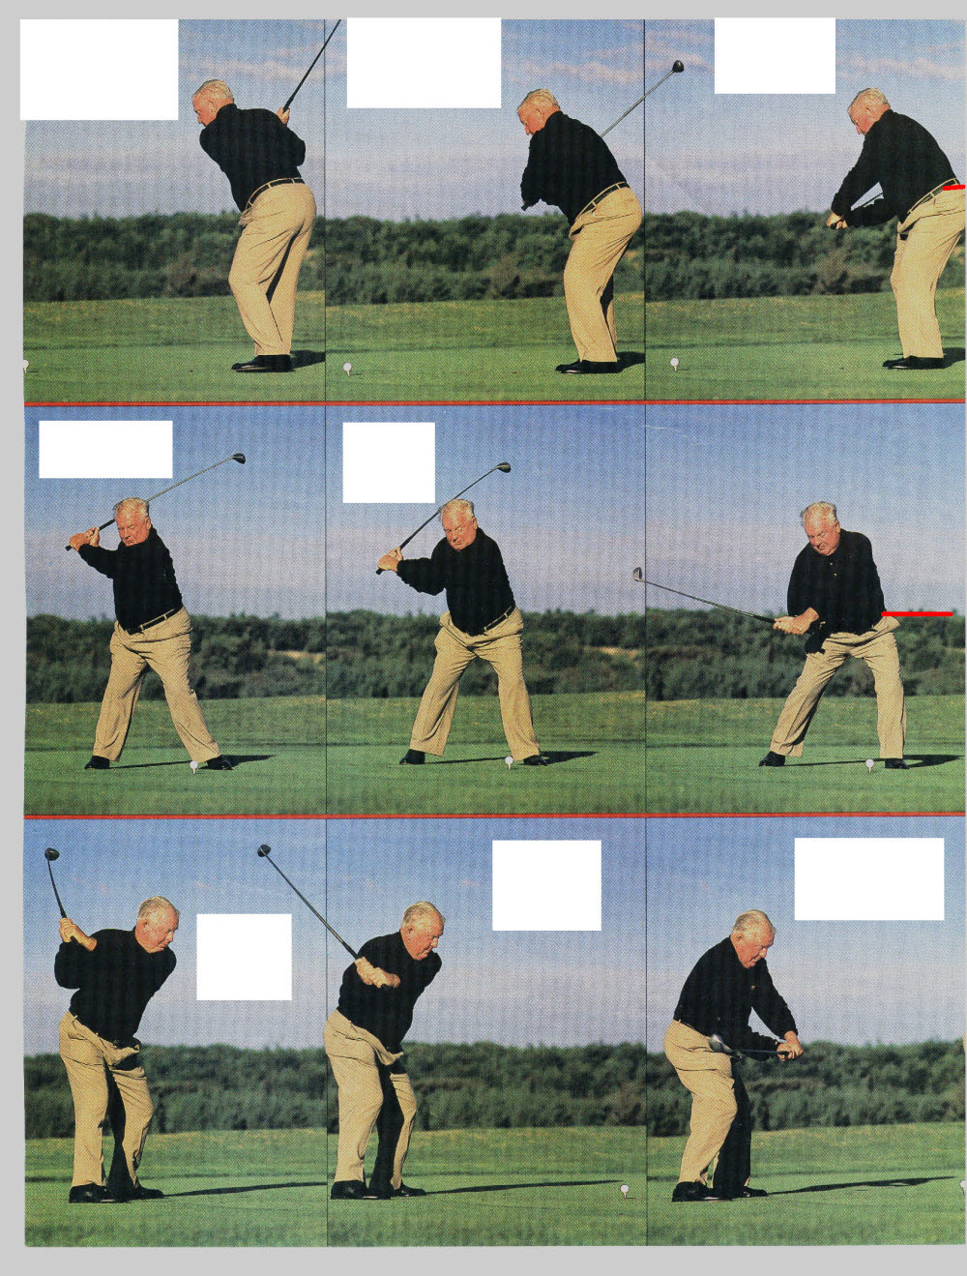

At the top, Moe’s right shoulder and hip are in line; NO TORQUING OF THE RIGHT SHOULDER TO THE RIGHT HIP.
Moe practiced sitting into his knees and dropping his hands backward and downward for an hour a night when he was a teenager. Any shifting of the weight to the left was a consequence of the sitting into his knees. Moe’s hips remained parallel to the ground and lowered several inches due to the sit down.
Moe’s head remained over his right knee.

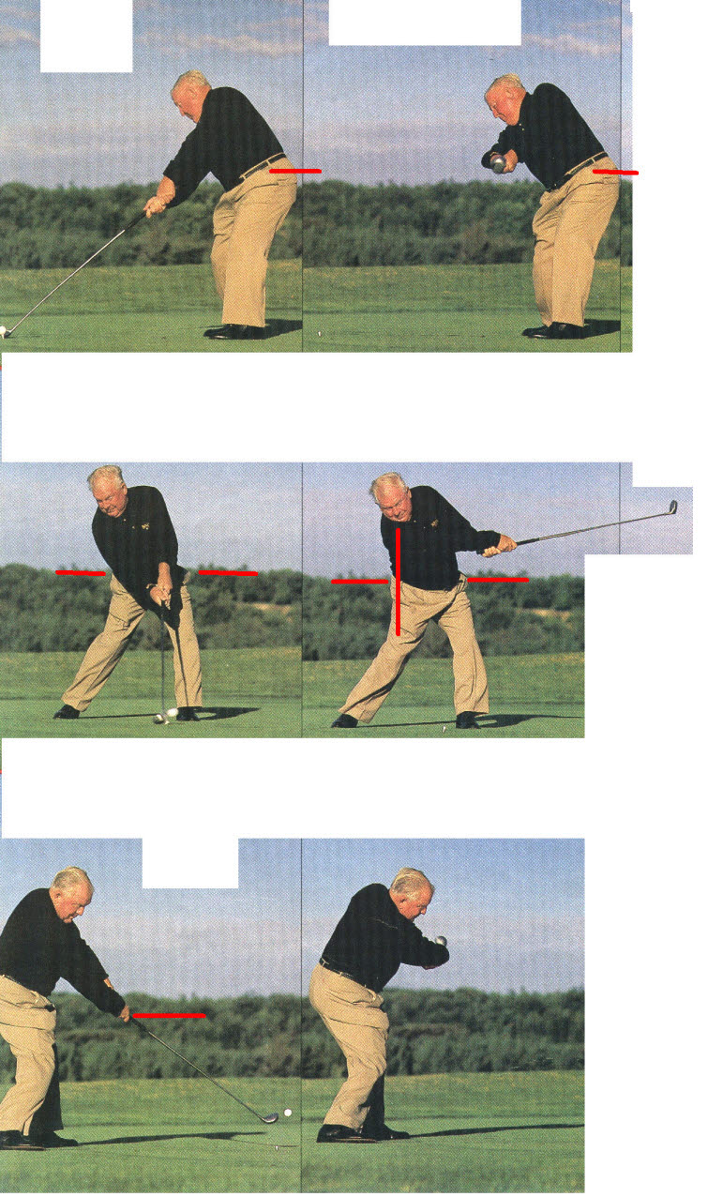
Moe’s hips remain below his address position because Moe’s is using a Single-Axis grip and does not have to rise upward and backward, as physics demands, when using the Two-Axis traditional grip.

Moe’s feet remain flat on the ground for optimum body balance.

His head remains over his right knee far into the release.
His eyes are still focused on the hitting area far into the release.

Moe’s right hand has returned to the same position as address. Only a Single-Axis grip allows this.

In order not to drive the clubhead into the ground, all Two-Axis grips require the spine to move upward and backward and the hands to be above the address position. The Two-Axis grip tries to straighten into a Single-Axis due the inertia of the club head moving on a tangent to the curve.

McLean’s Triple X-Factor:
- Torqueing the shoulders to the hips; X-Factor Stretch
- Hip Rise
- Head Swivel
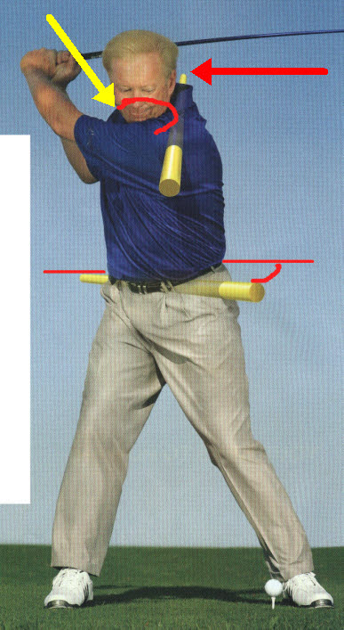
- X-Factor Stretch:
According to McLean, the X-Factor measures the amount of coil between the shoulders and the hips; the X-Factor stretch is how much that coil increases from the top to the first move in the move down.

(JK’s comments:
- The yellow sponges do NOT point in the direction of McLean’s hips or shoulders.
- McLean’s perception is that his right shoulder is where I have drawn the large red arrow at the back of the yellow sponge. His right shoulder is where I have drawn the large yellow arrow. There is a distance gap of around 80 degrees.
- You might be thinking that McLean doesn’t really think that his right shoulder is where I have drawn the large red arrow. You would be 100% wrong! McLean sees his perceptions. Reality does not exist for him. End of JK analysis for this photo).
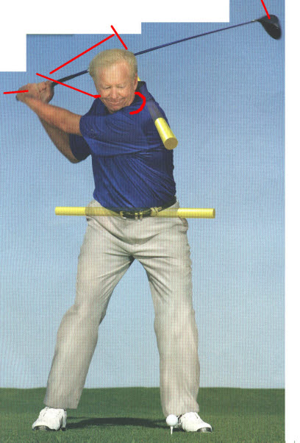
McLean’s perceptions of the start of the first move down:
The upper body and lower body should work independently. The hips and legs separate from the upper body and start the forward. That’s when the X-Factor peaks.

(JK’s comments:
If you take a close look at the relationship between his hips, shoulders, arms and hands, you will see that everything rotated together. There was no additional separation. I have drawn some red lines to show the position of McLean’s right and left shoulder versus his incorrect perceptions. End of JK analysis for this photo).

(JK Comments: It is easy to show that virtually all clubhead speed comes from arm speed. The body is just a support and stabilizer for the fast moving arms. The only thing you receive from torqueing the shoulders to the hips is back and shoulder pain.
Many of the site members ask why I don’t show my analysis to the authors. The reason is very simple. No golf teaching perceptionist will ever let scientific facts get in the way of a theory! They simply try to destroy you. I am not interested in them. I am interested in providing the members of my site with scientific information. You make your own decision as to who is correct and who is incorrect. End of JK Comments).

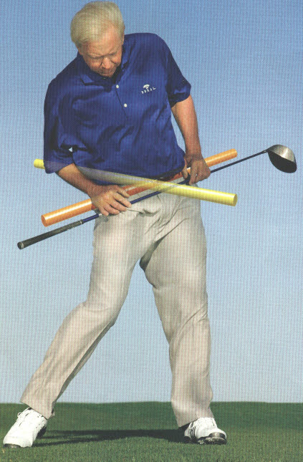
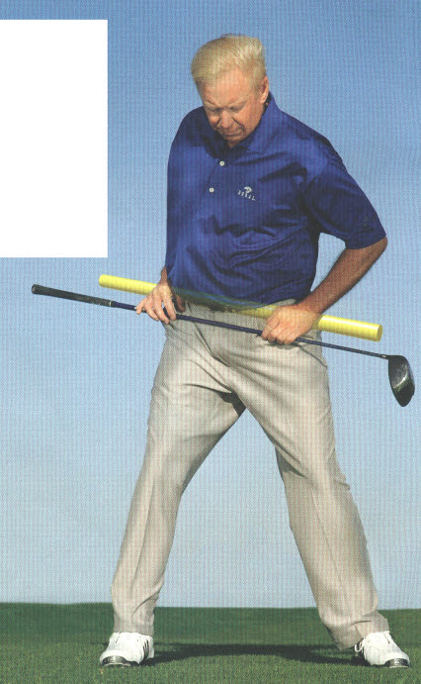

- Hip Rise
McLean’s incorrect perception:
The right hip moves higher on the backswing, and the left hip moves even higher on the forward swing. It’s this hip rise that creates a power surge, the player springing up from the ground.

(JK’s comments: The hip rise, the left shoulder rise and the straightening of the left leg occurs with all Two-Axis grips. Body center must move upward and backward to allow for the straightening of the right arm levers. McLean’s incorrect perception is that the hips, rotating on a plane parallel to the ground, can create club head speed in the shoulders and arm planes that are moving on totally different planes. The spine is the only connection between the hips and shoulders. If they are moving independent of the shoulders, what mechanism allows for the transfer of their very slow 2 to 5 mph speed? The scientific answer is: There is no mechanism for the transfer. If there were a mechanism, it would be so slow as to have no useful effect. McLean never gets the cause and effect scientifically correct. End of JK comments).

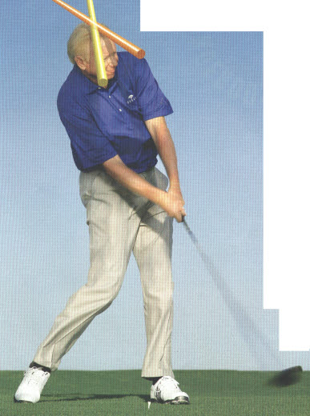
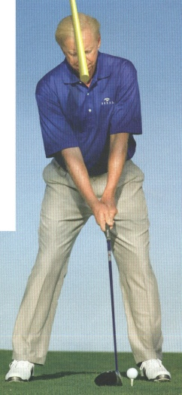
- Head Swivel
Turning your head through with the center of your body improves upper-body rotation and weight transfer to the left leg. The key is to release your eyes and head simultaneously. You’ll hit it longer and straighter by releasing your head and eyes earlier.

(JK’s comments: McLean lists several tour players who’s heads turn just after impact as support for his theories. The scientific reason every one of them have their heads rotated is because of the death grip (they all have the left hand knuckles on top of the club). Their hips must be facing the target and their shoulders are around 35 degrees open at impact in order not to snap hook the ball. There is no other place for their head to be but rotated. Again, McLean’s cause and effect is 100% incorrect. End of JK comments)

JK Summary: So to see if I understand McLean’s theory:
- Torque your shoulders to your hips in the backstroke until there is as much pain in your back and shoulders as you can stand. Then snap your left hip to the left as fast as you can to create even more pain in your back and shoulders.
- Rotate and get your left hip as high off the ground as possible, as this is how the ground supplies the power to the hip rotation.
- Rotate your head and eyes toward the target through impact to increase distance and accuracy.

If McLean and Golf Digest did not affect a lot of golfers, I would be rolling on the floor laughing! Sadly, his teachings does a lot of harm to uneducated golfers.

All traditional Two-Axis grips have the following mechanics
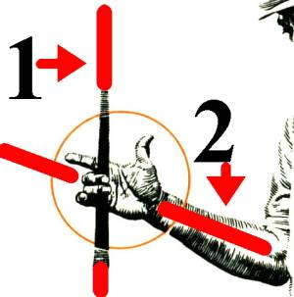
In a traditional grip, the right forearm and the shaft have an angle between them. It is anatomically impossible to swing a two-axis system on a single plane.

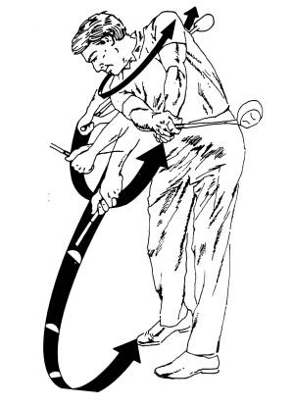
In all traditional golf stroke, scientific observation shows:
- The shoulders rotate on one plane. The hips rotate on a plane that is both different and independent of the shoulders’ plane; hip speed cannot affect clubhead speed- there is no mechanism for transferring hip speed (2mph) since the shoulders and hips rotate independent of each other.
- The arms rotate on a 2nd oblique plane.
- The hands rotate on a 3rd plane (through 180 degrees from waist high in the downstroke to waist high after impact).
- The clubhead rotates on a 4th plane.
- The clubface rotates on a 5th plane.
- Body center is moving upward and backward through impact (The spine ALLWAYS moves upward and backward).
The motion is simply too complex for the average human to consistently have the clubface pointing in the correct direction. Tour Players hit acceptable shots 60 to 70 percent of the time.
What statistics show:
- you can practice all you want,
- play all you want,
- have the best equipment traditional companies offer,
You will never hit more fairways and greens. YOUR PERSONAL COORDINATION BARRIER determines the number of times your clubface will be square at impact. If your score improves, it will be in the short game.

