Phil Mickelson

Mickelson has always been:
- A long hitter – well over 300 yards.
- Below tour average in fairways hit in regulation.

An analysis of his mechanics provides some reasons.

Phil’s address is the traditional 2-axis 4-lever trailing arm set up.
- It is anatomically impossible to rotate a two-axis trailing arm system on a single plane.
- The two-axis must straighten due the clubhead’s curved inertia path; body center must move upward and backward as the clubhead moves through impact.

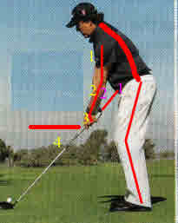

The horizontal red line in the left photo shows the height of Phil’s left hand from the ground at address.

The red lines on his arms show the two-axis four-lever trailing arm set up.

The red lines on his spine and leg show his address posture angles.

The red line on his left leg show his knee flex.

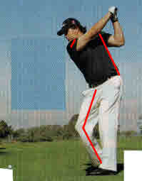
Good position of shoulders, arms and hands at the top of the stroke.

Left shoulder close to in line with left hip (no torqueing of left shoulder to left hip).

Excessive and unnecessary rearward right leg motion.

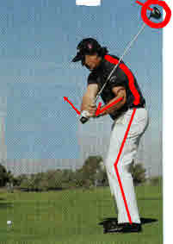

Phil sits into his knees and moves his hands backward and downward with additional cocking of the left wrist (additional stretch reflex; the clubhead is still far above his left shoulder).
Phil’s shoulders have not returned to the address position (back still toward the target).

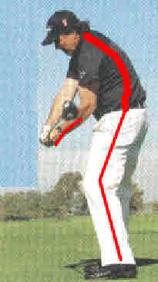
Slight change in shoulders and hips and leg rotation.

Slight straightening of the left triceps and left forearm lever.

Major release of the stretch reflex of the left wrist (from clubhead well above head to parallel to the ground – major clubhead speed producer).

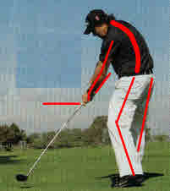
Left heel coming off the ground and more rotation of the lower body. Weight shifting to right leg (standing on one leg; non-optimum body balance)

Left Photo: Body has moved upward and backward; spine and legs.
Hands are substantially higher than at address.
Most of the weight is on the right leg; non-optimum body balance
Left arm and shaft trying to form a straight line.

This would be a good impact position if Phil’s feet were flat on the ground and his hips and legs were close to his address position.

Right leg straight; body center moving upward and backward because of the 2-axis 4-lever left arm and shaft.

If Mickelson would keep both feet flat on the ground from address to impact, he could reduce all the non-optimum lower body motion. His upper body and arm motion is satisfactory for the coordination limited, 2-axis, 4-lever, forearm rotation system.

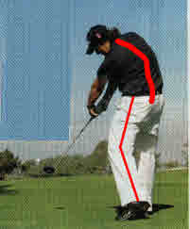
Release shows 180 degrees of forearm rotation from waist high in the backstroke to waist high in the follow through.

Even for one of the great players, coordination of this movement greater than 60% of the time is extremely difficult.

