Tiger Woods – 79 Wins - #2

Some athletes possess physical characteristics that offer an advantage in specific sports. Tiger Woods physical characteristics are ideal for golf.
Having these characteristics gave him an advantage. However, this is not why Tiger Woods is the second all time winner on the PGA tour. Tiger was the second all time winner because of his mental toughness; he refused to lose.

Tiger’s mechanics had all the fundamentals.
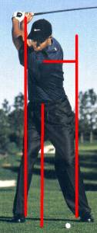 | Top of Back Stroke:  - Braced into his right leg at the top of the backstroke  - Back and waist rotate away from the target  - Both feet flat on the ground for stability  - Head just inside his right foot  - Left shoulder rotated under chin; additional 30 degrees from his address position  - Right shoulder in line with his right hip; rotated from 30 degrees in front of his right hip to in line with his right hip.  Note: Shoulders rotate independent of each other.

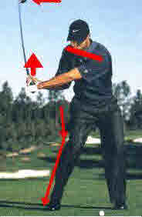 | Start of Downstroke:  - Sits into his knees; this major move at the start of the downstroke lets the hands move backward and downward while keeping the back to the target – sets the hands into the power slot!  - Left knee directly over the left big toe.  - Around waist high in the downstroke, the relationship between the hands and shoulders has changed only slightly  - Head in same position as it was at the top.

Waist High in the Downstroke:

- Back still to the target.
- Clubhead well inside and behind.
- Right wrist fully cocked for maximum right wrist stretch reflex.
- Feet flat on the ground for stability; body is a stabilizer – arms produce clubhead speed.

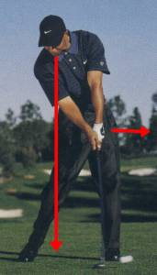 | Waist High to Impact:  - Shoulders return to square to the target line  - Right triceps straighten the right forearm – major clubhead speed producer.  - Right wrist stretch reflex activates – major clubhead speed producer  - Head remained in the same position from the start of the downstroke to impact.  NOTE: Hip rotation is an idiosyncratic learned mechanics. Hips only produce motion that must be timed. Hips rotation does not produce clubhead speed.

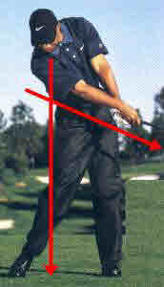 | Release:  - Forearms rotate through 180 degrees from waist high in the downstroke to the release position shown in the photo.  - This rotation occurs in approximately 0.06 seconds. The timing of this 180 degree rotation separates every level of golfers. Those who time this rotation the best are the most accurate players.

Has Tiger Woods Changed his Swing Mechanics?

One of these sets of photos is from 2018 and the other is from 2001!
Can you see difference?

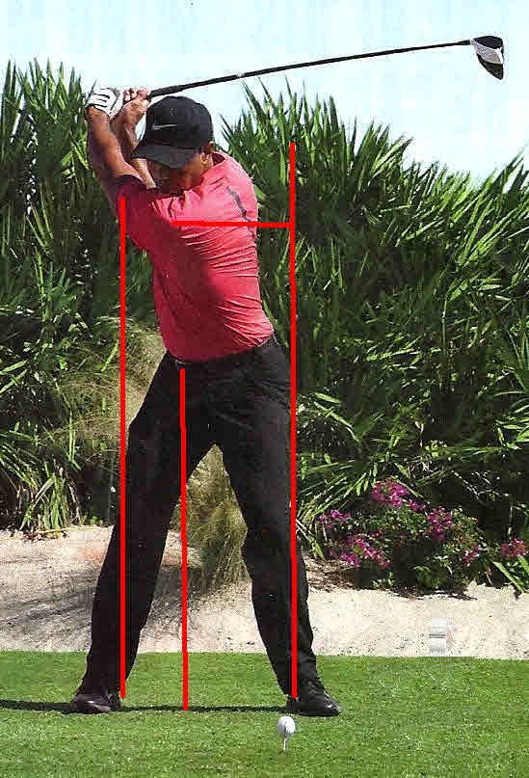
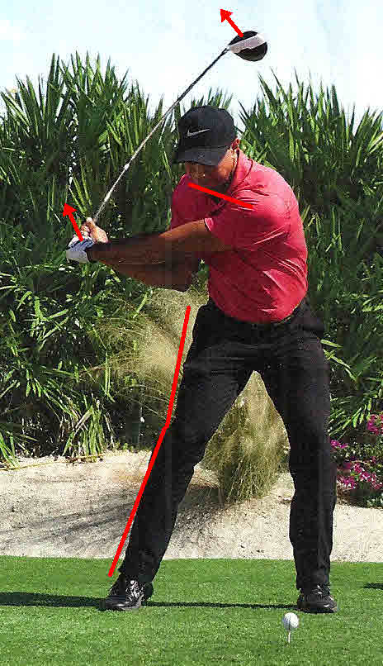
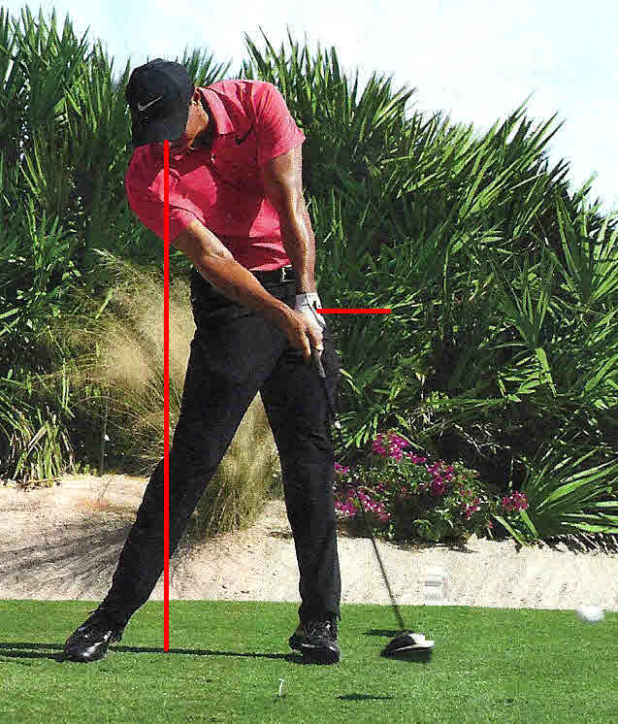
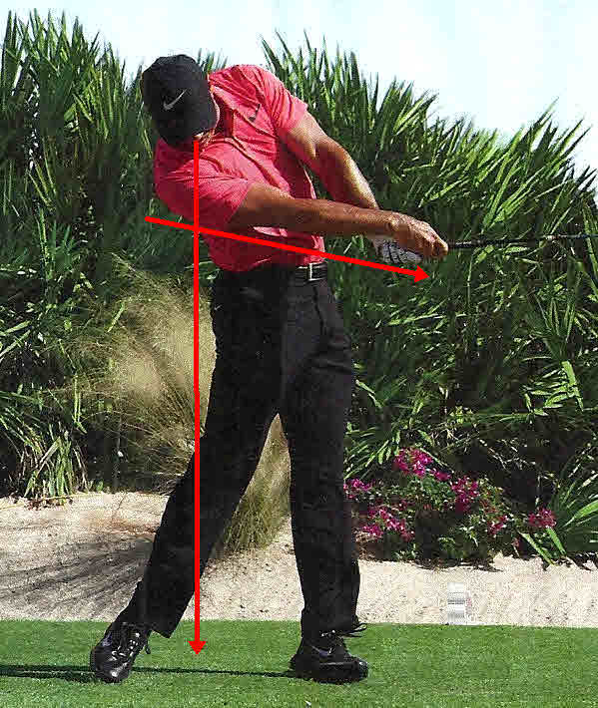

It should seem obvious that there has not been a mechanical change. Brain patterns established as youth are permanent. They never go away. Trying to change these patterns has had a negative effect on numerous Tour winners.

